**Assignment 2:**

Task 1: Understanding Power Query Editor (Data Cleaning & Transformation)

1. Import the dataset into Power BI using Power Query Editor.

2. Perform the following transformations:

* Remove missing values & duplicates.
* Change data types (e.g., Date, Currency, Categories).
* Split full names into first and last names.
* Merge tables based on keys (e.g., Orders & Customers).

3. Save a step-by-step documentation of transformations done.

Step 1: Open Power Bi Desktop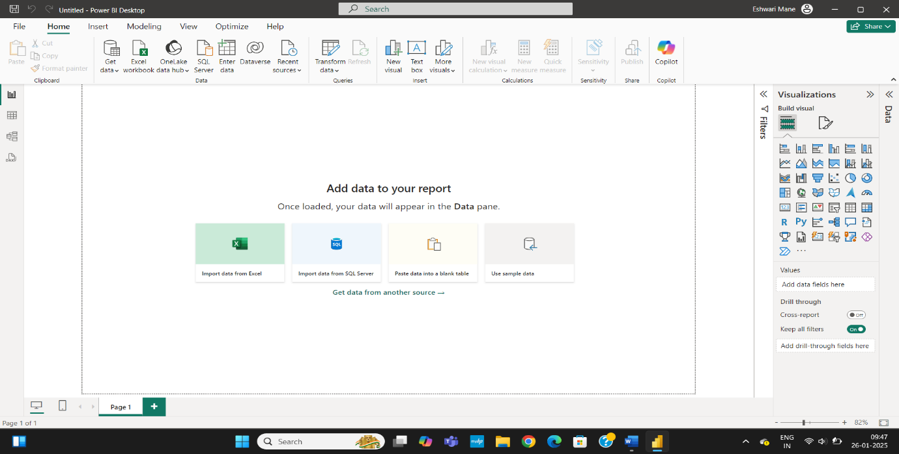

Step 2: Click the Get Data Option and under it click on Excel Workbook

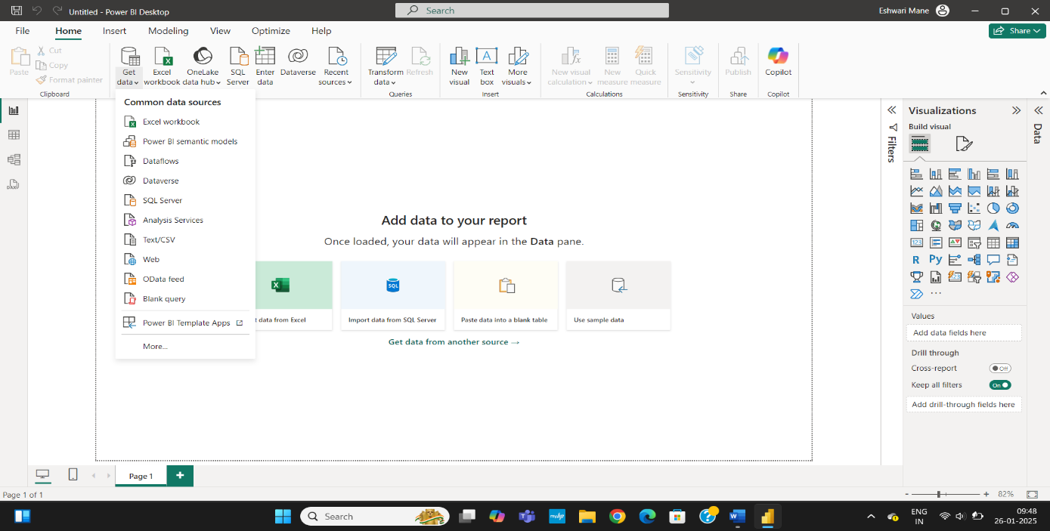



Step 3: Select the dataset Product and click on all files instead of Excel Files

Step 4: Click on Load Data

Step 5: Repeat step 3 and 4 till you insert whatever datasets to needed

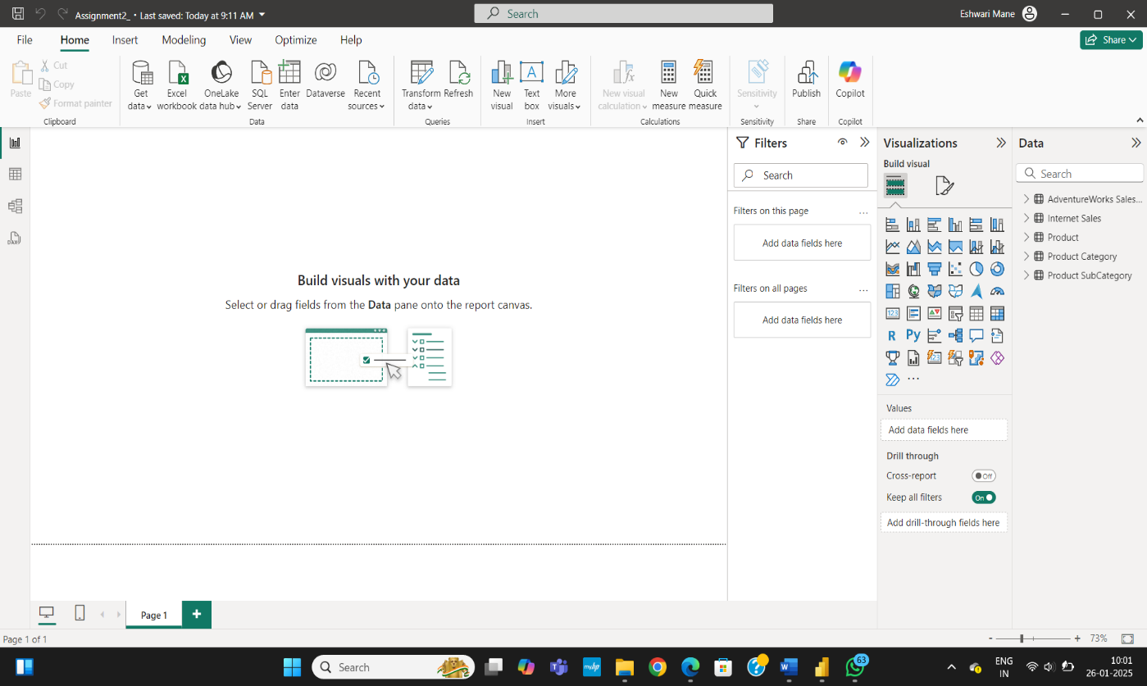

Step 6 : Click on Transform Data to Open Power Query Editor

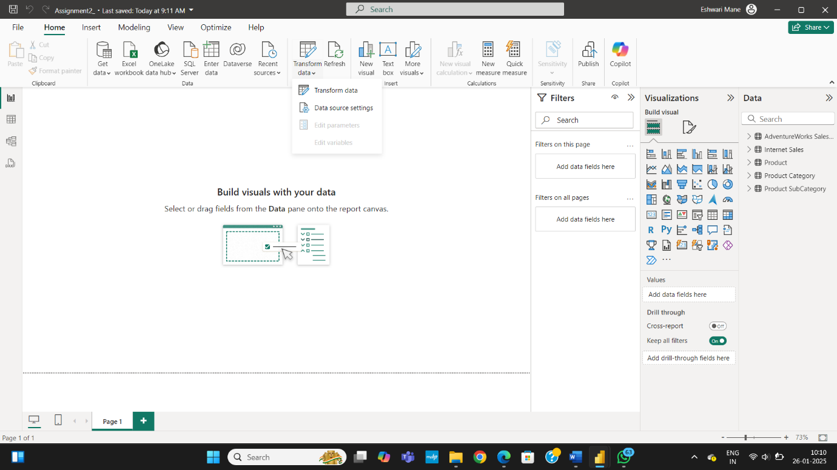

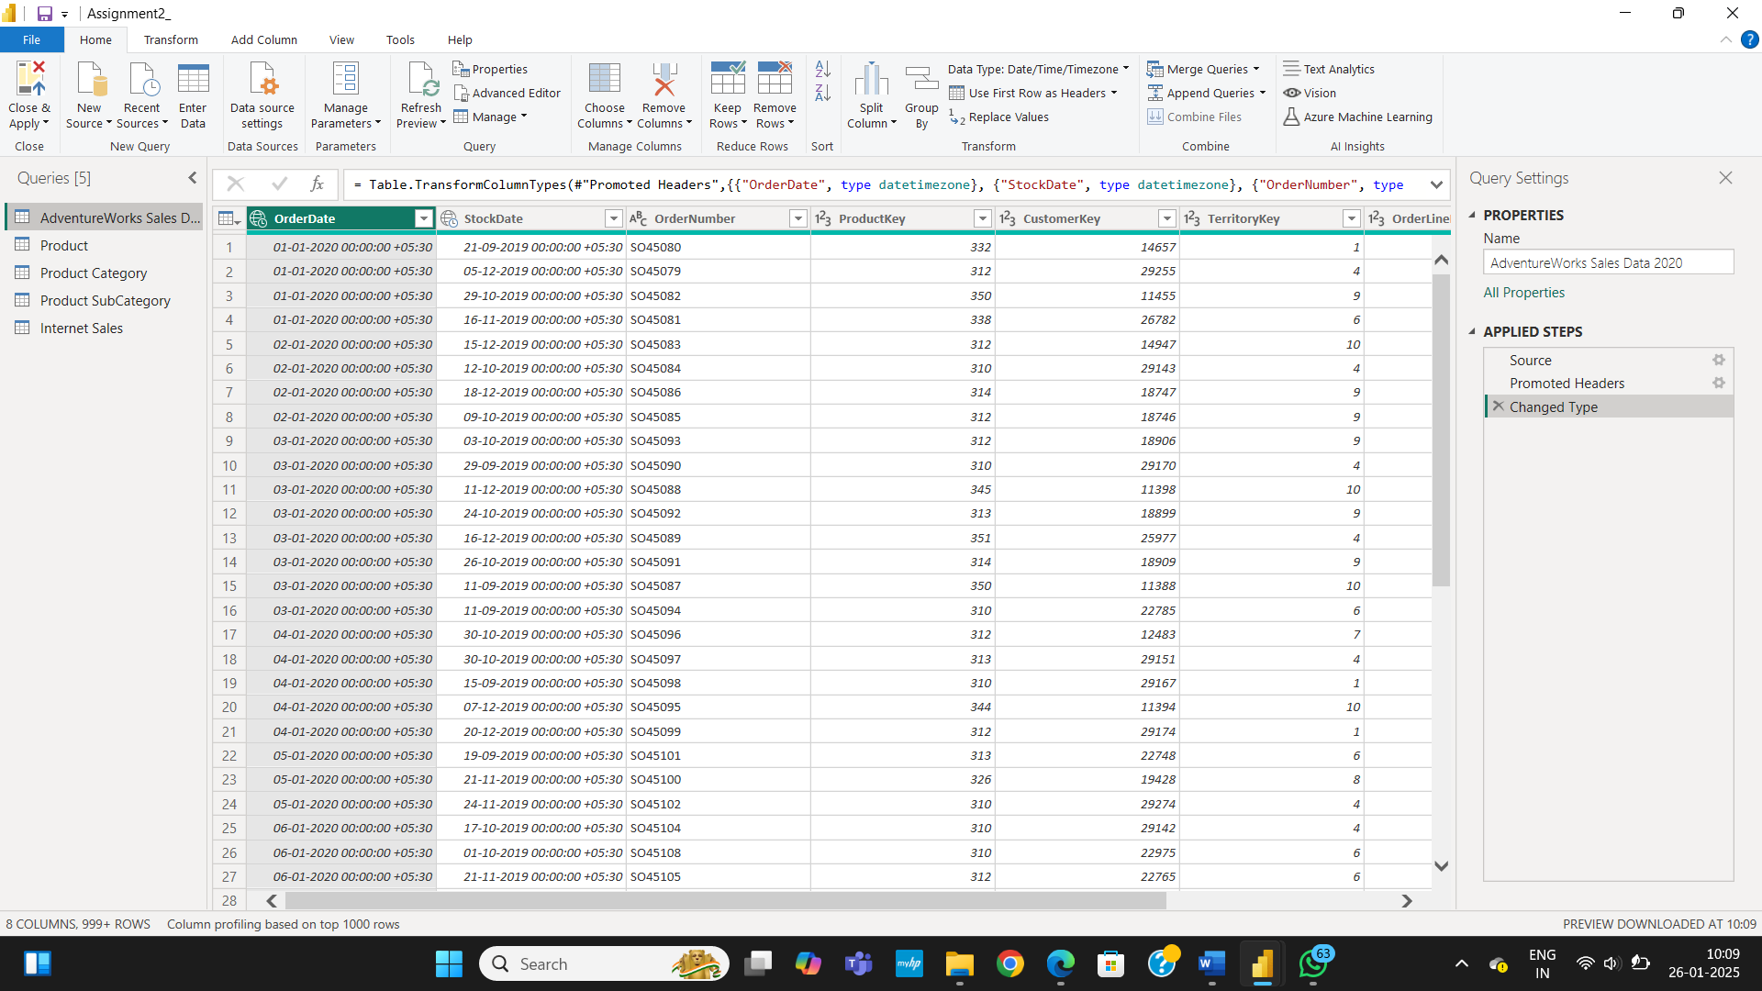

Step 8 : To remove NULL values in WeightUnitMeasureCode column click on the shown arrow and in the search button search NULL and deselect it, it will remove all null values of our column

Step 9: To remove NULL values in product Size Unit Measure Code column click on the shown arrow and in the search button search NULL and deselect it, it will remove all null values of our column . Repeat this process for different columns.

colum

Step 7 : Power Query Editor will be opened

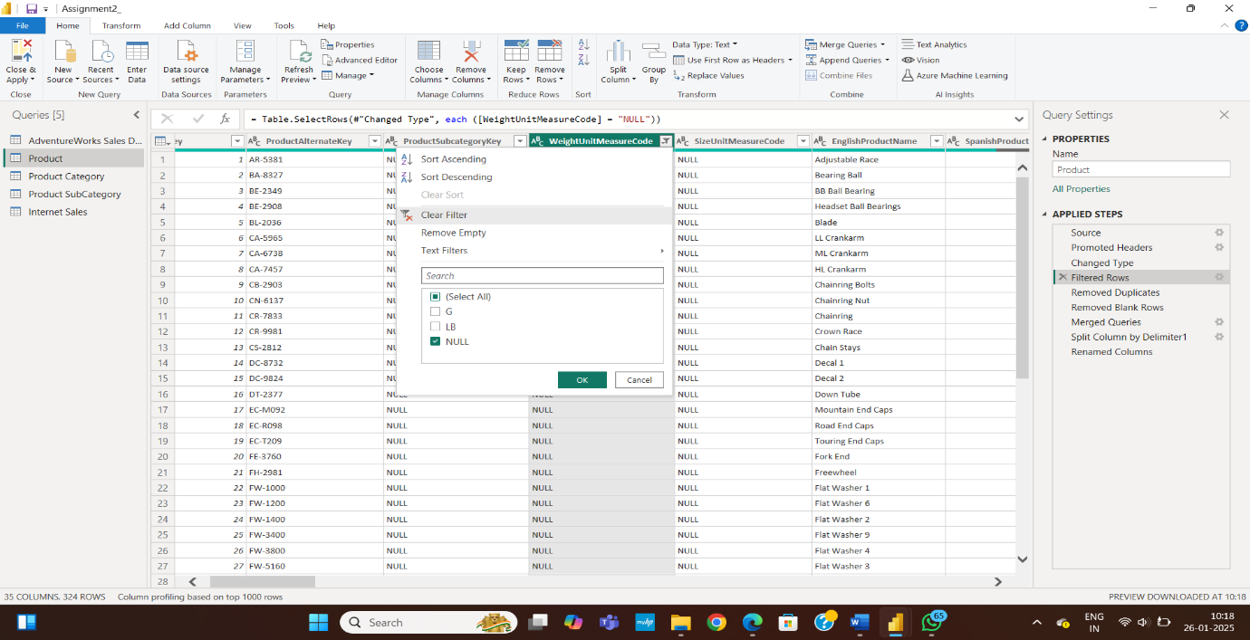

Step 10 : Changes will be save as Filtered Rows if you want to undo it click on **X**

Step 11: To Remove Duplicate first select the column EnglishProductName then click on remove Row From that select remove Duplicates.

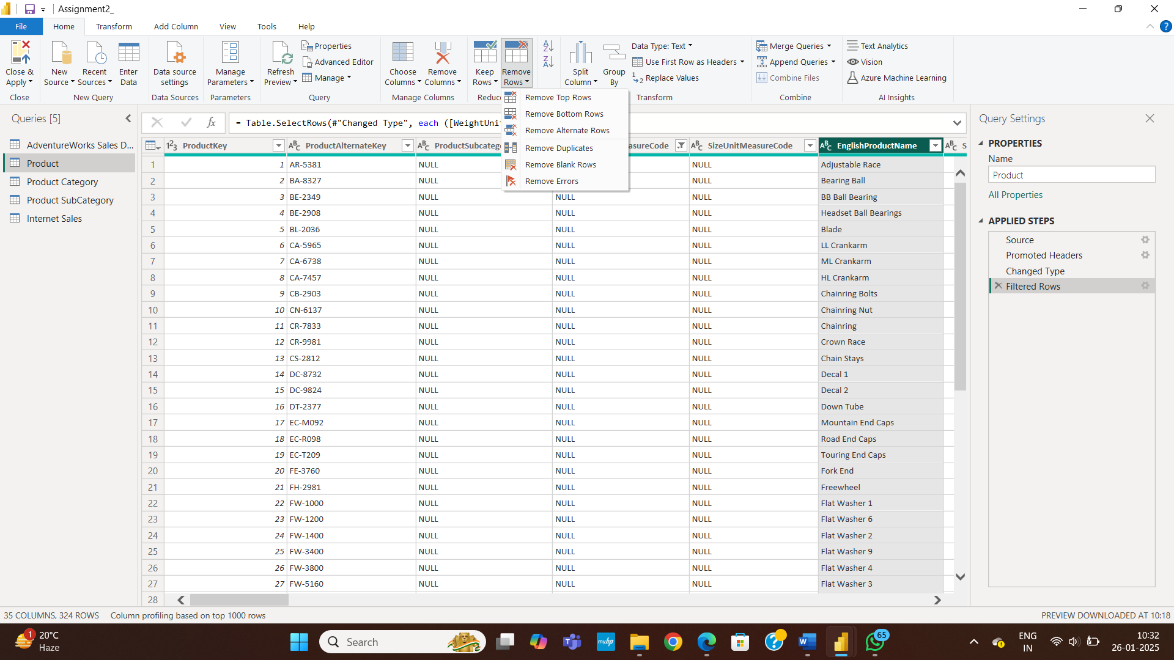

Step 12 : Duplicates Will be removed.

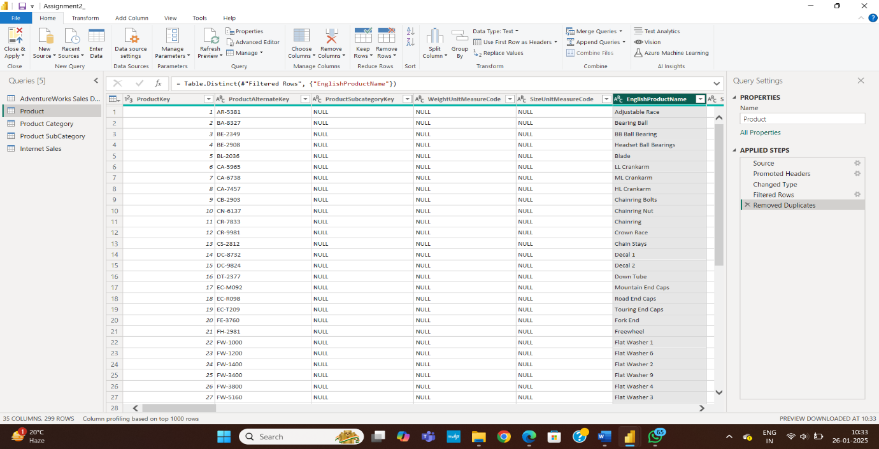

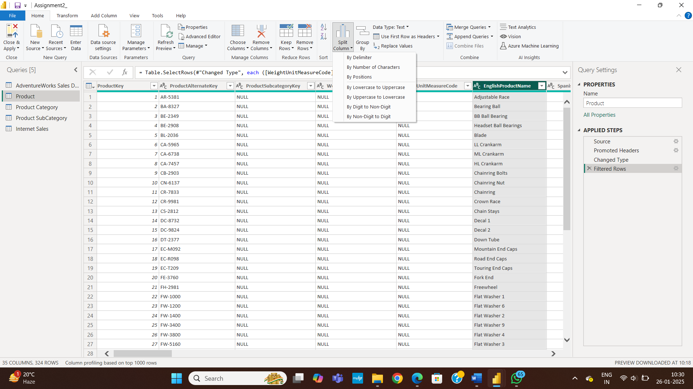

Step 13 : Select the English Product Name Column for Splitting the column and then click on Split Column . Click on By Delimiter option.

Step 14 : Select Space and Left-most-delimiter and click Ok

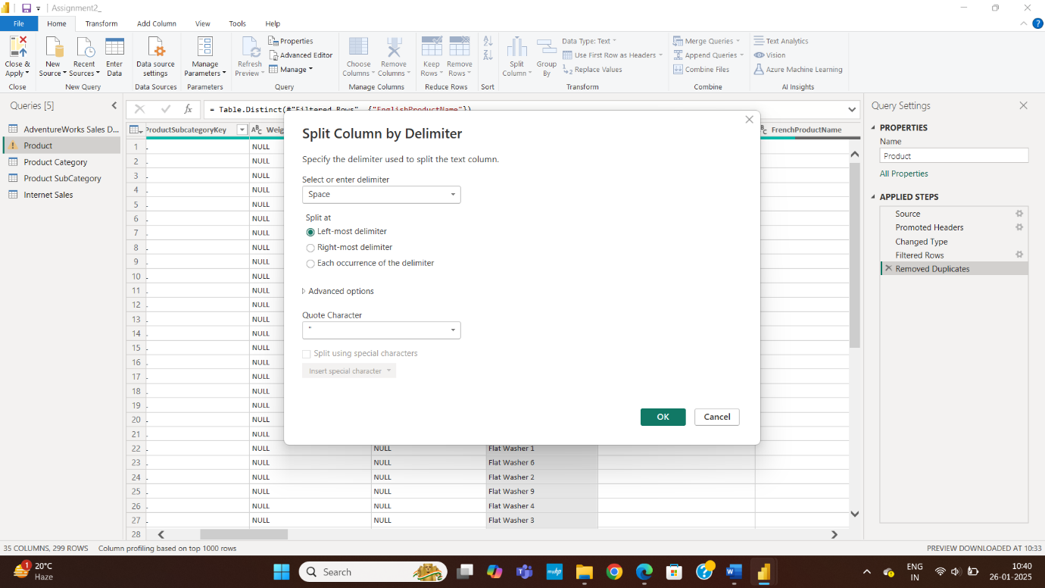

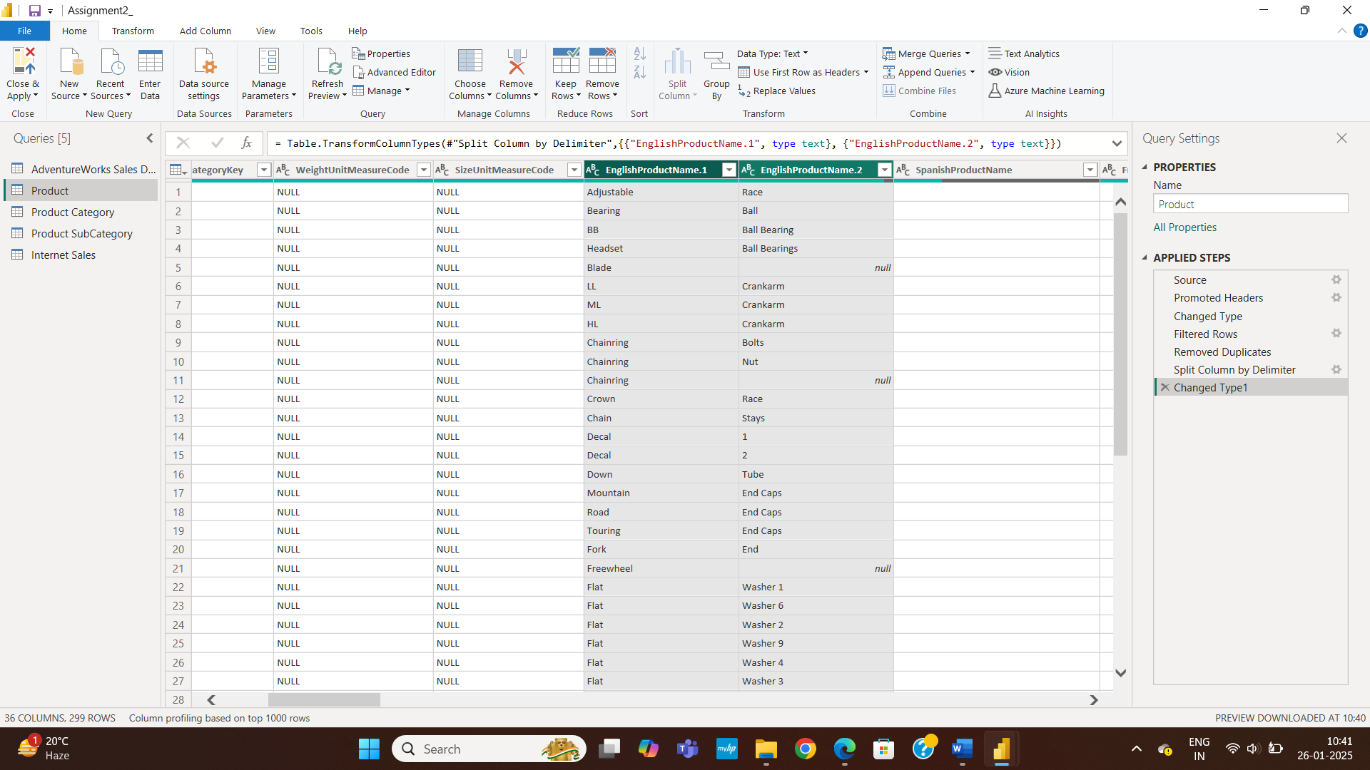

Step 15 : Column will get split and we get two columns EnglishProductName.1 and EnglishProductName.2 .

Step 16 : To Rename the columns .Select the column and right click on it then click on rename and enter the new name.

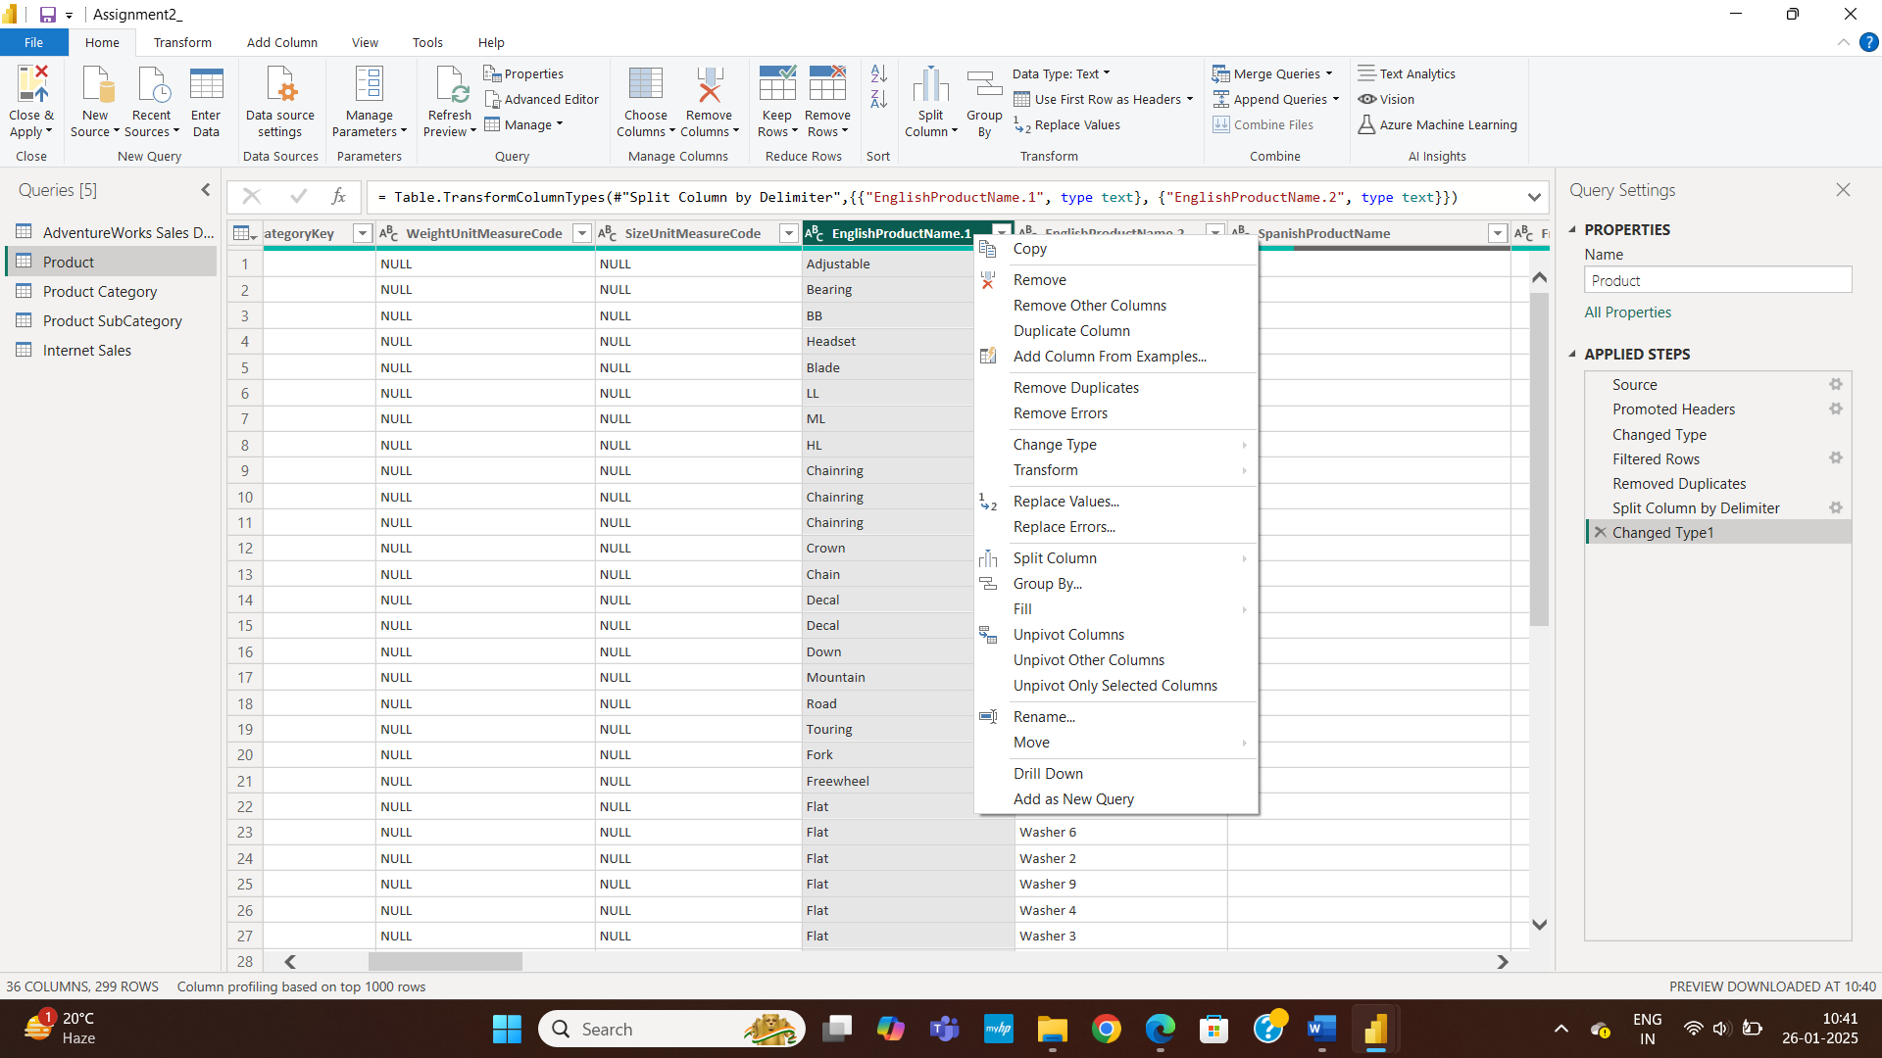

Step 17 : Column EnglishProductName.1 will be named as FirstName and EnglishProductName.2 as LastName.

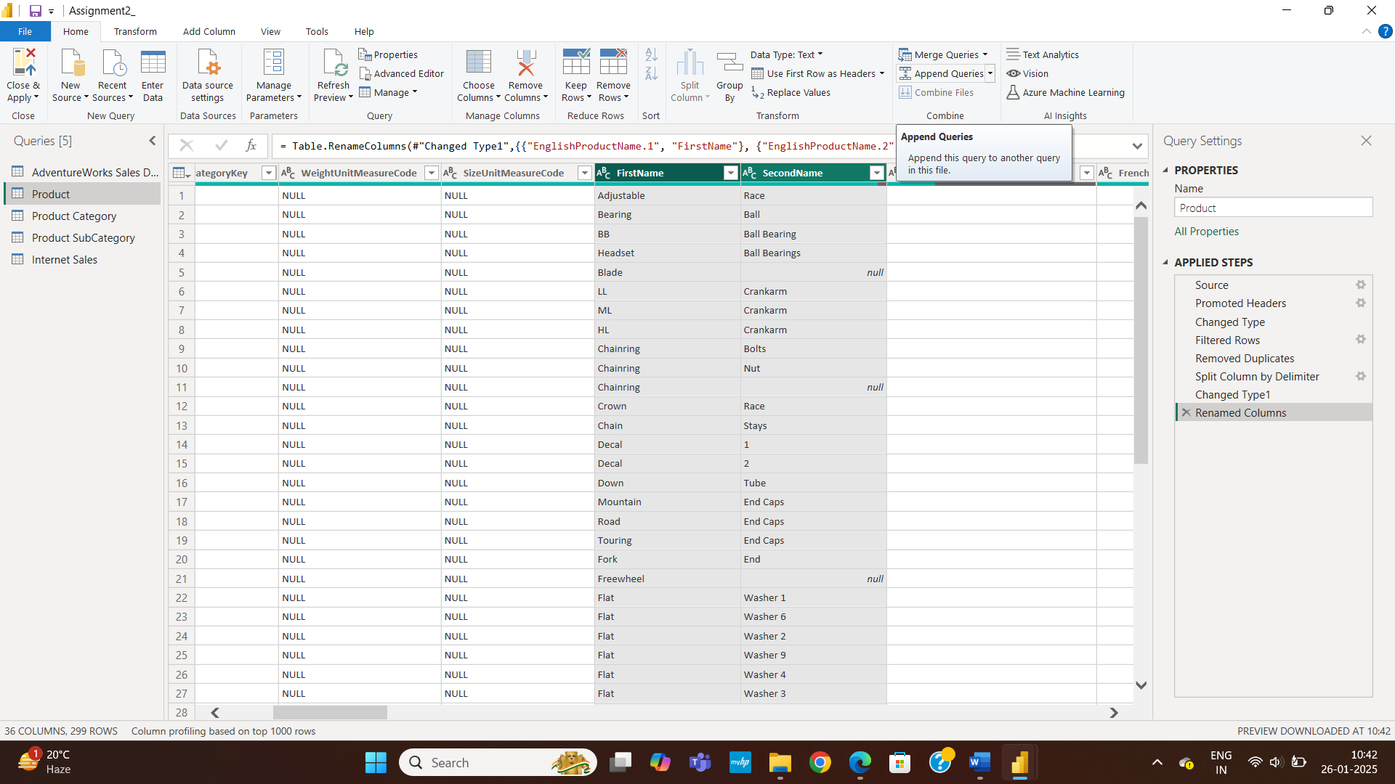

Step 18 : To Change the datatype . Here we will change the Date Datatype of AdventureWorks Sales Dataset . So 1st Select the column OrderDate and StockDate and Go to DataType . Click on it and select the the datatype Date/Time/Timezone.

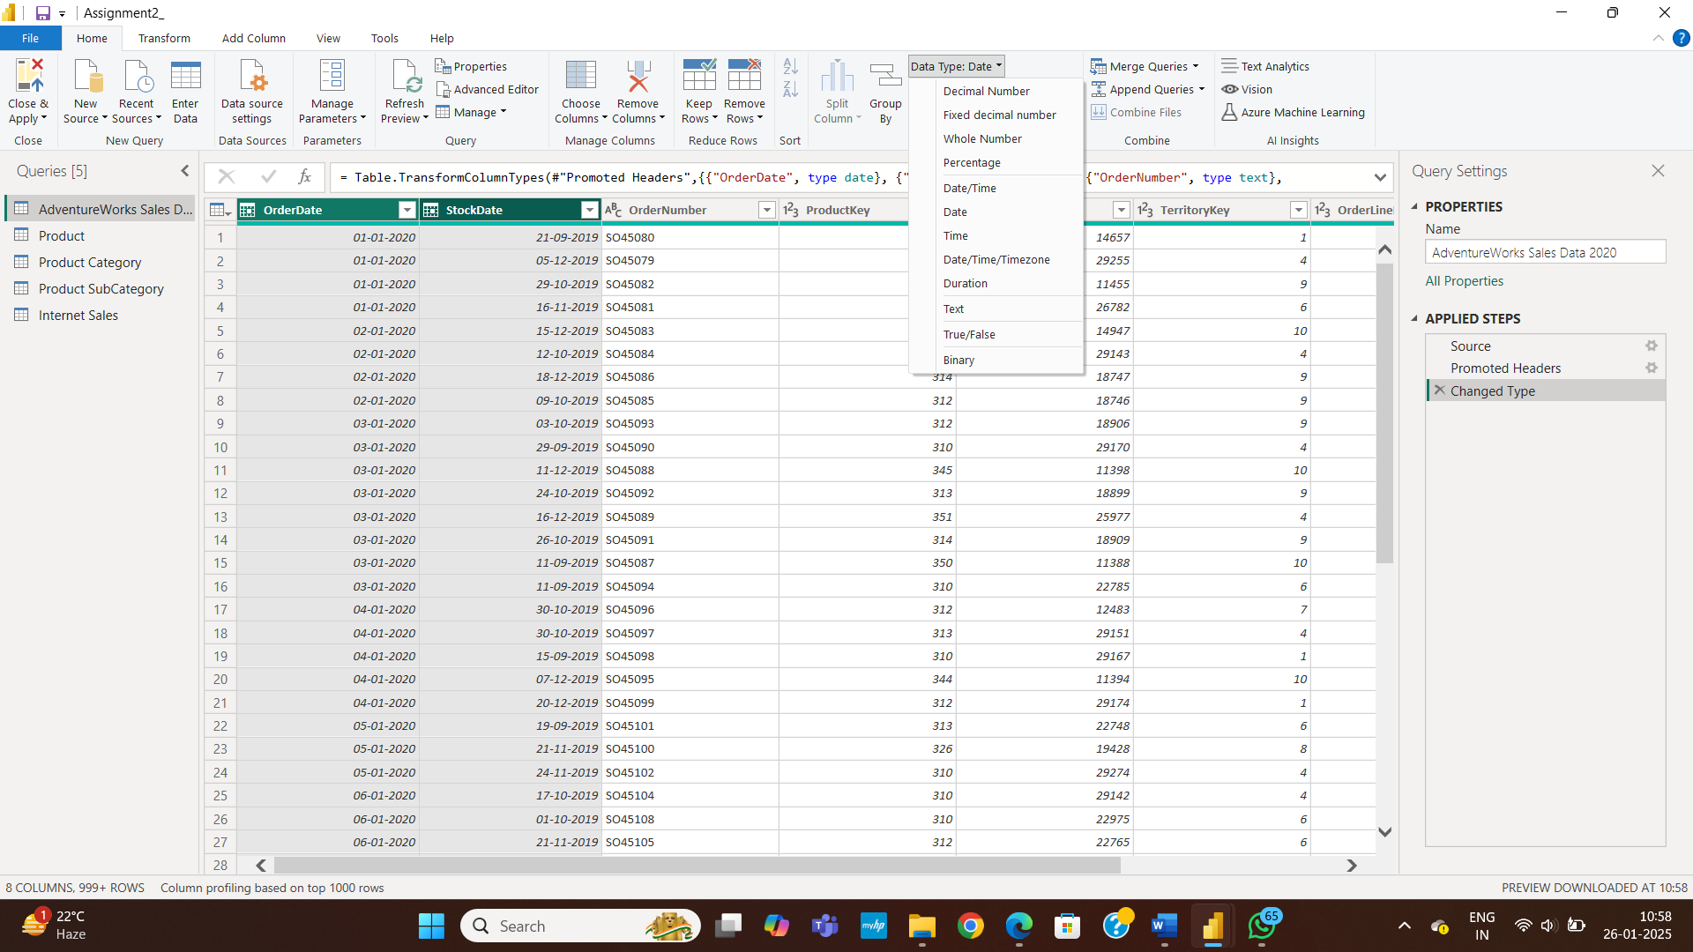

Step 19 Then Click on Replace current Values and the Datatypes will get changed.

We will do this same process for currency and Categories columns only select the correct datatype.

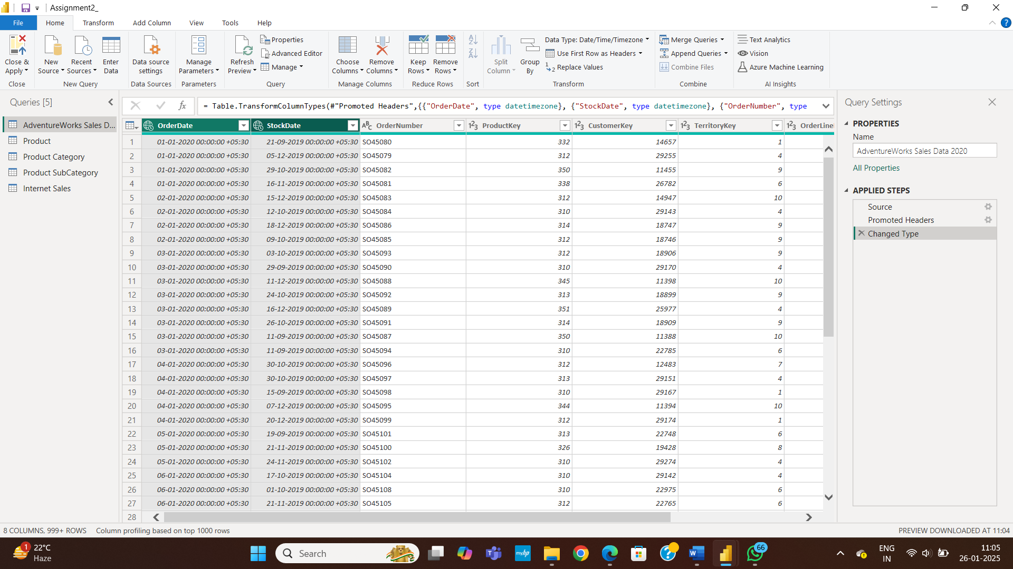

Step 20 : Our column is removed and the operation is named as ‘removed column’

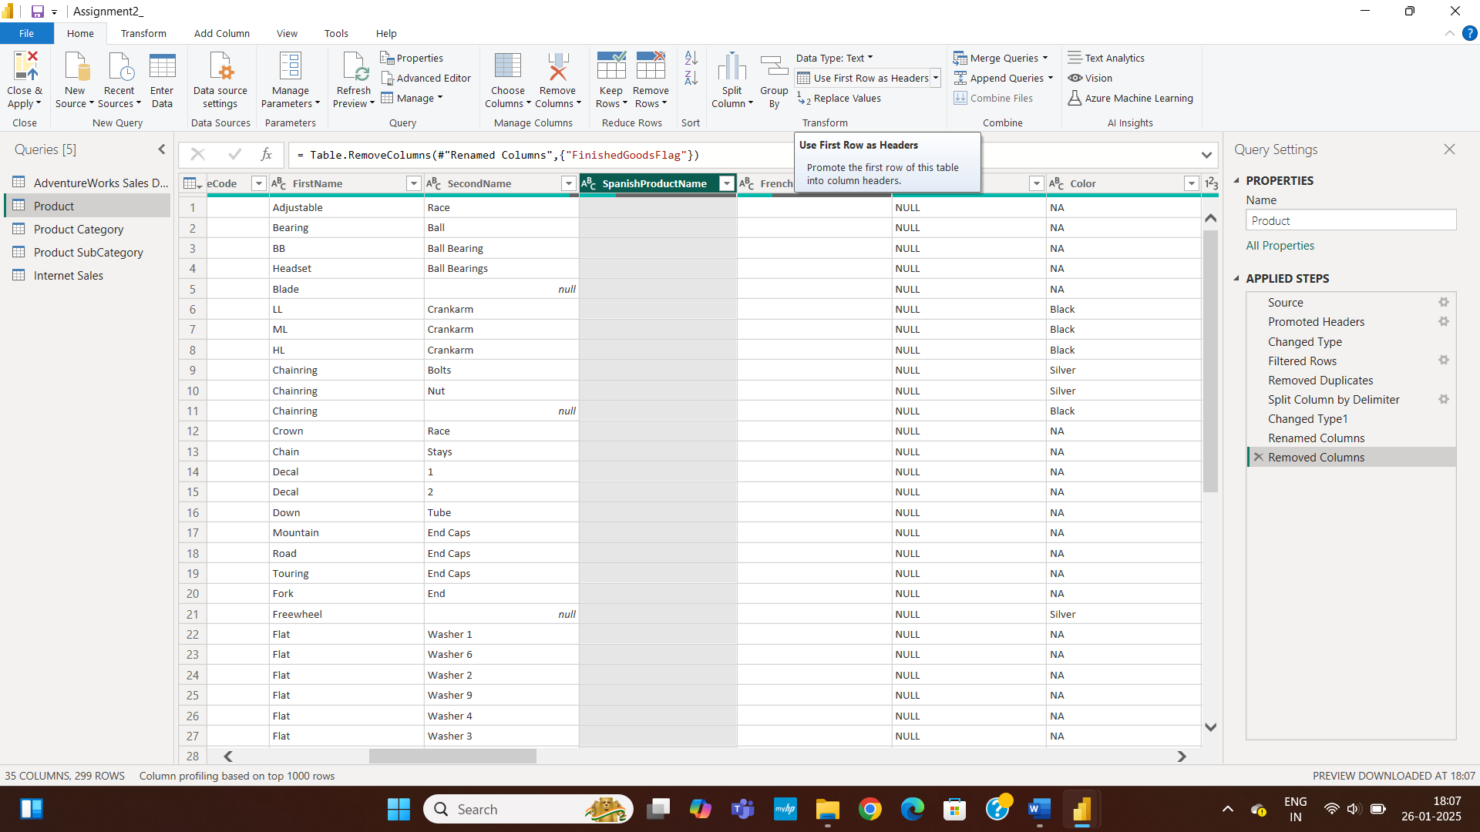



Step 21 : In ‘Spanish Product Name’ column we can see some blank values lets remove it.

Step 22 : Deselect the blank under the search button it will remove all blank values in our column.

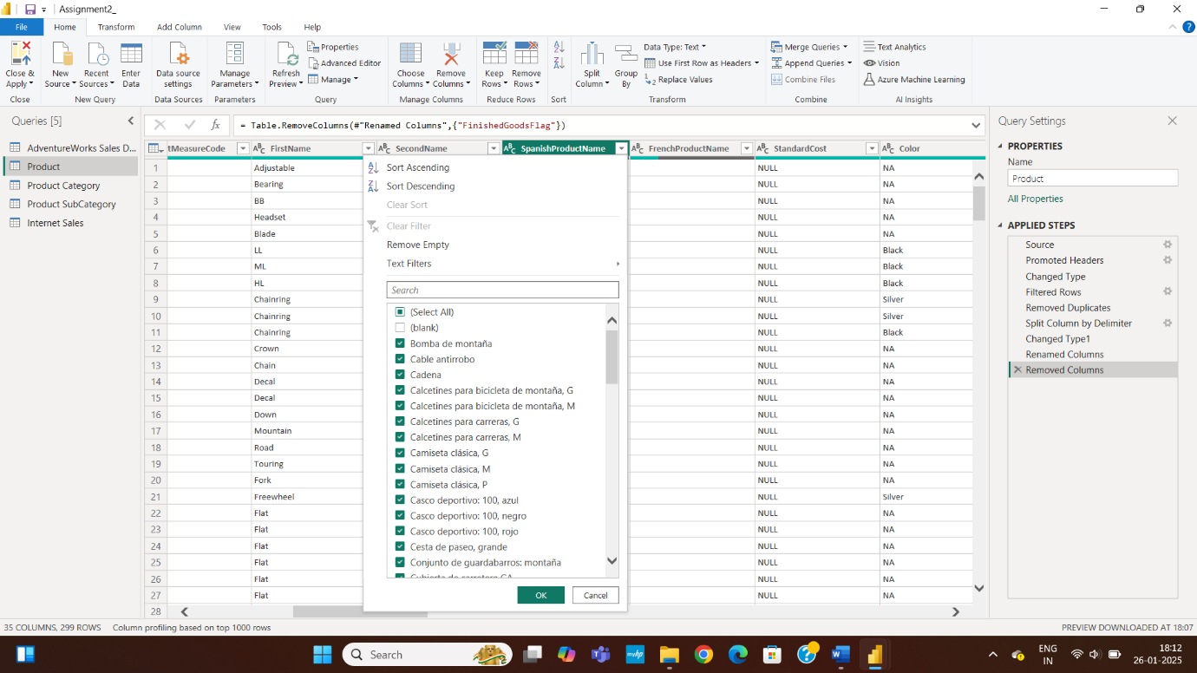

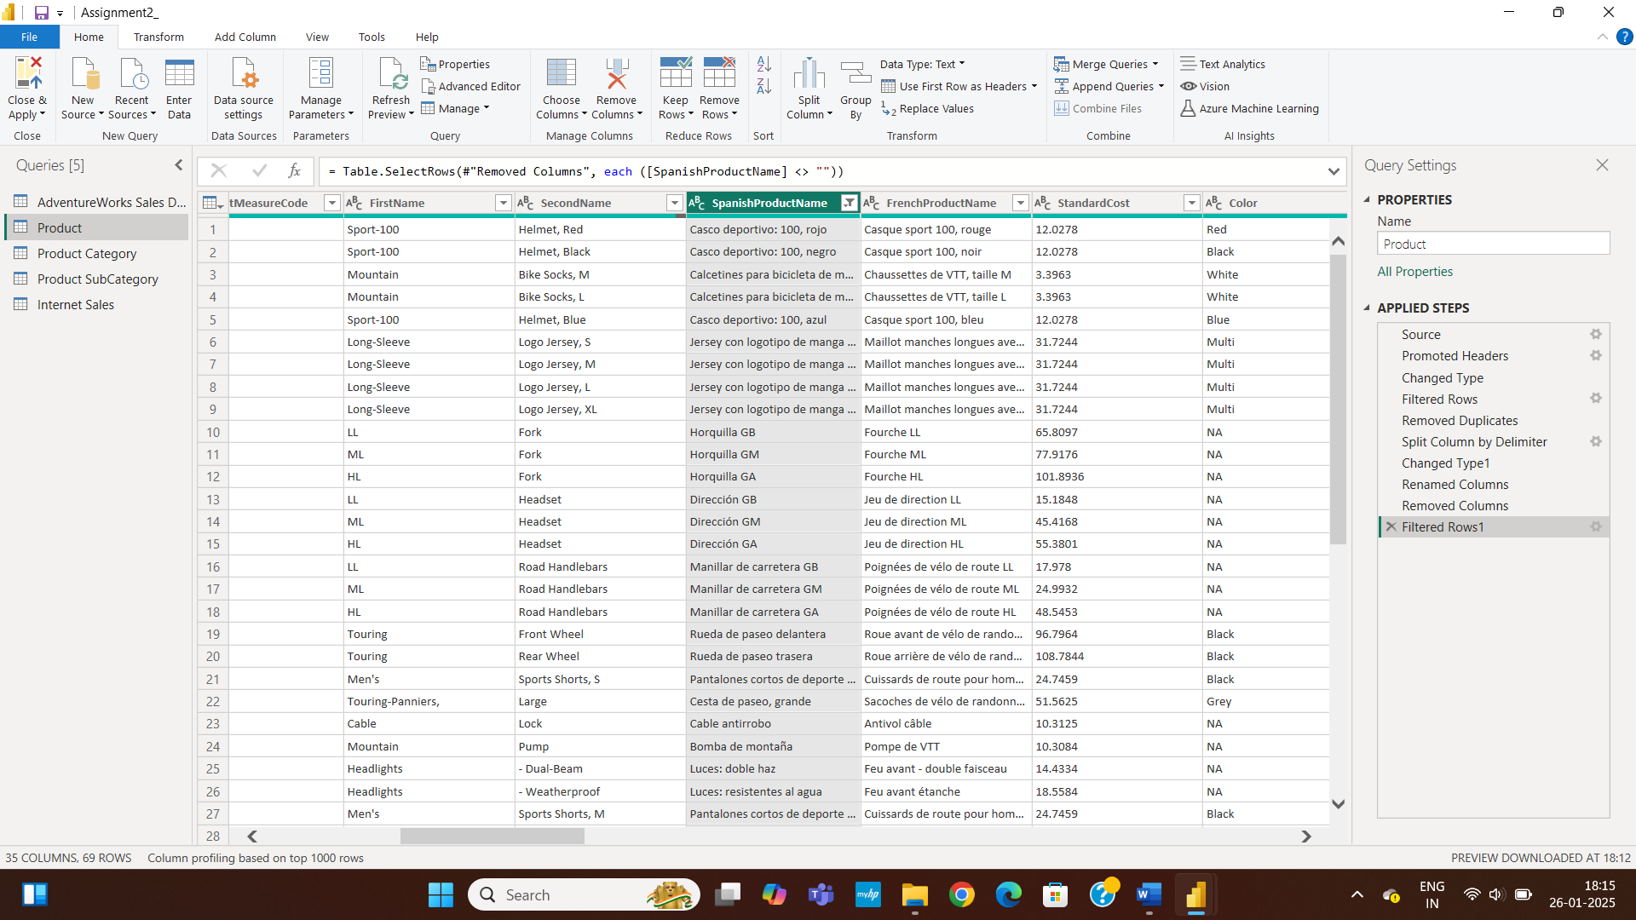

Step 24 : As we can see our ‘standard Cost’ column is of datatype ‘float’ for better understanding of data convert the datatype to ‘whole number’ for doing this click on ‘data type’ option .

Step 23 : As we can see our blank values are removed and operation is named as ‘filtered rows 1’ .

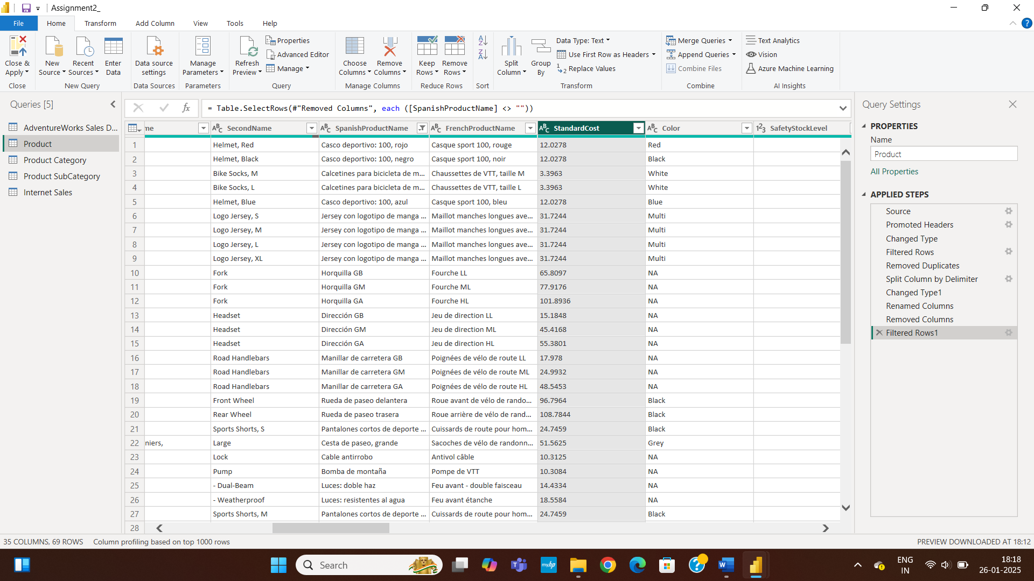

Step 25 : From the below option select the datatype as ‘whole number’ .

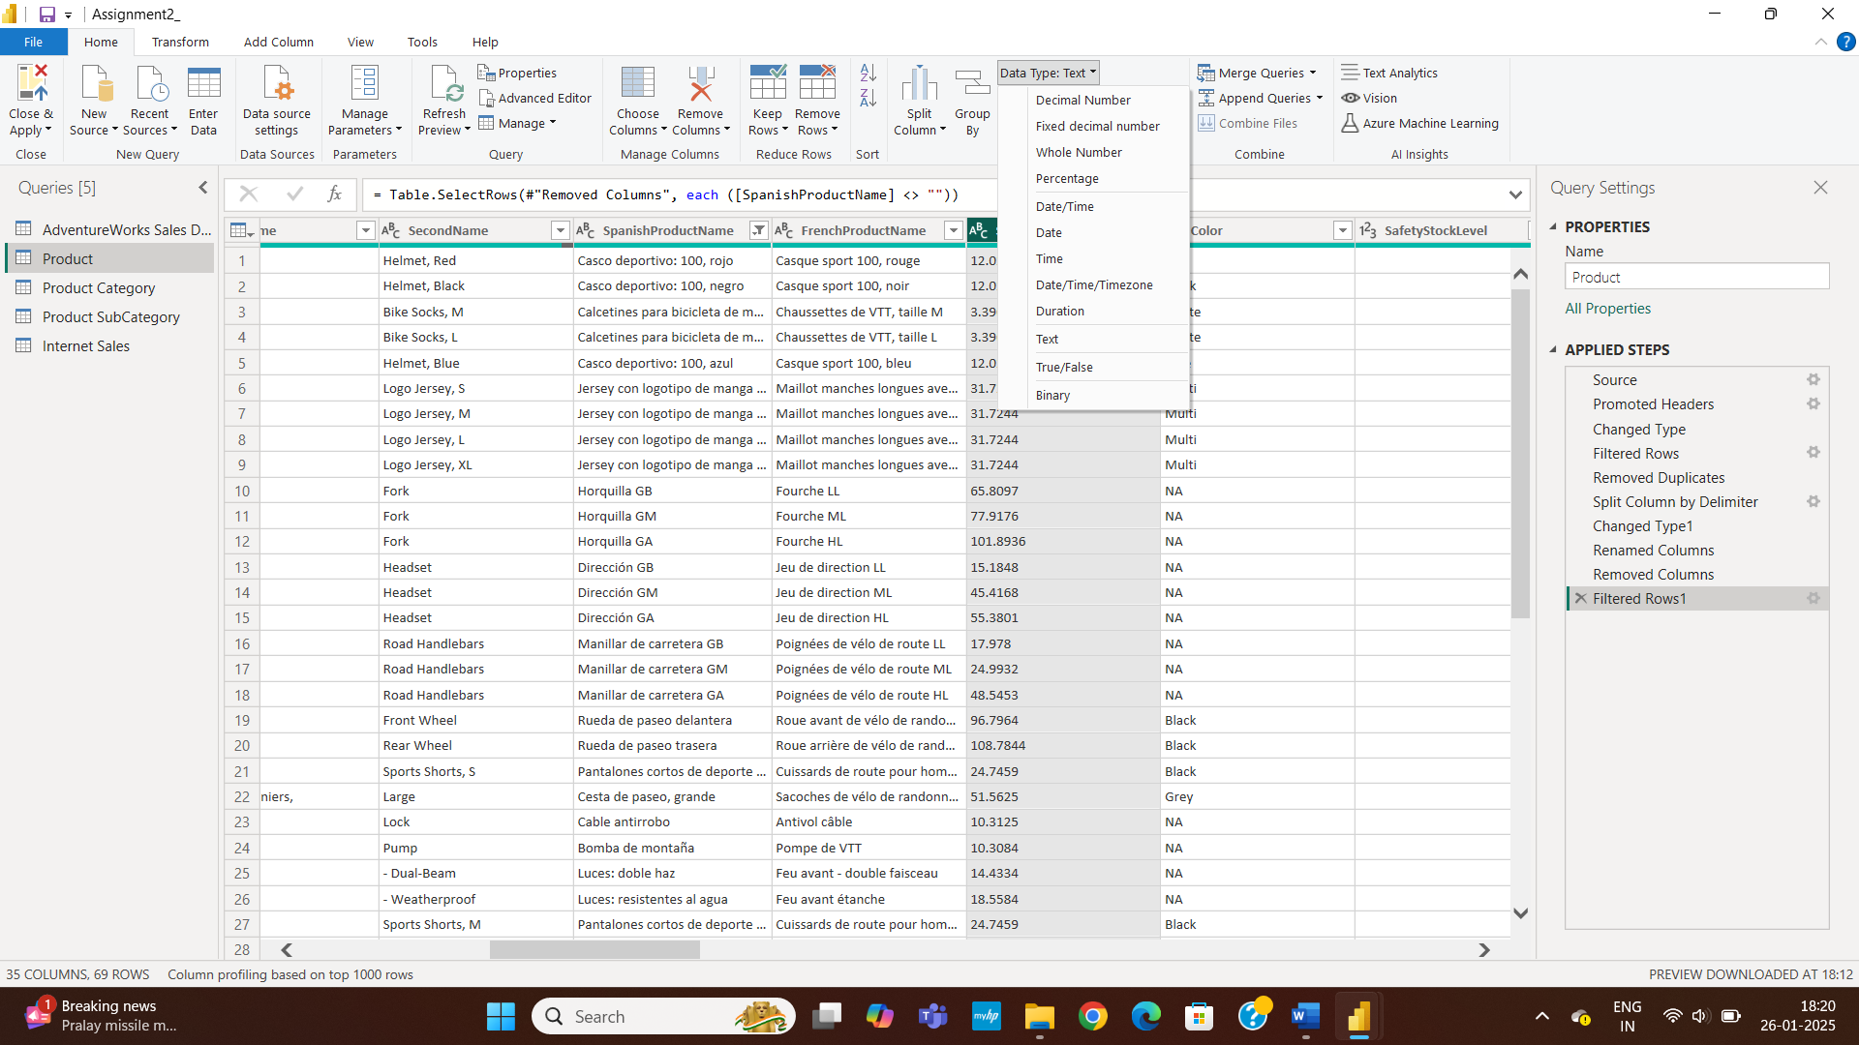

Step 26 : Our resultant column is changed to datatype ‘whole number’ and operation is named as ‘changed type 1’ .

Step 27 : As we can see our ‘List Price’ column is of datatype ‘float’ for better understanding of data convert the datatype to whole number for doing this click on ‘data type’ option .

Step 28 : From the below option select the datatype as ‘whole number’ .

Step 29 : We can see resultant column ‘list price’ is converted to datatype ‘whole number’ and the operation is named as ‘changed type 1’.

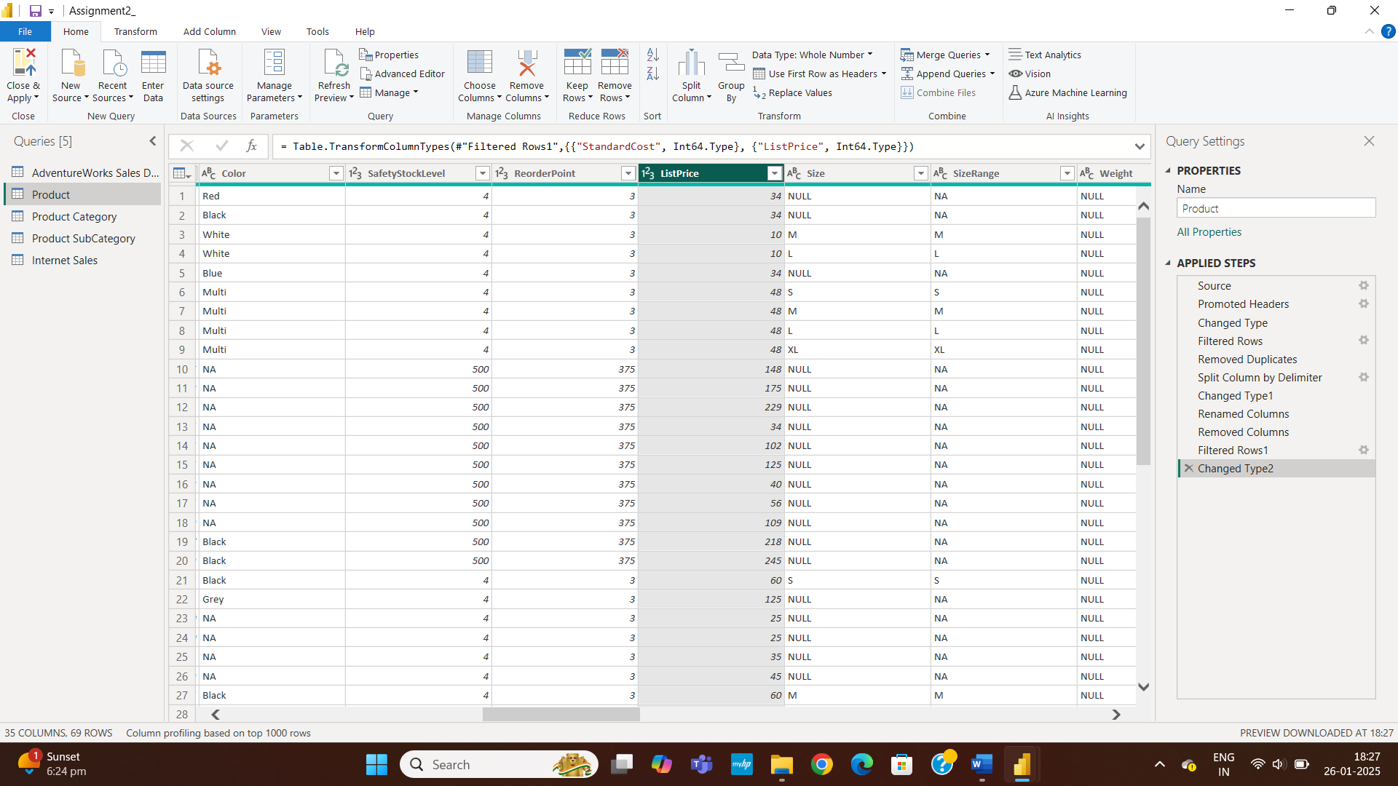

Step 31 : Select the table ‘product’ from the given option.

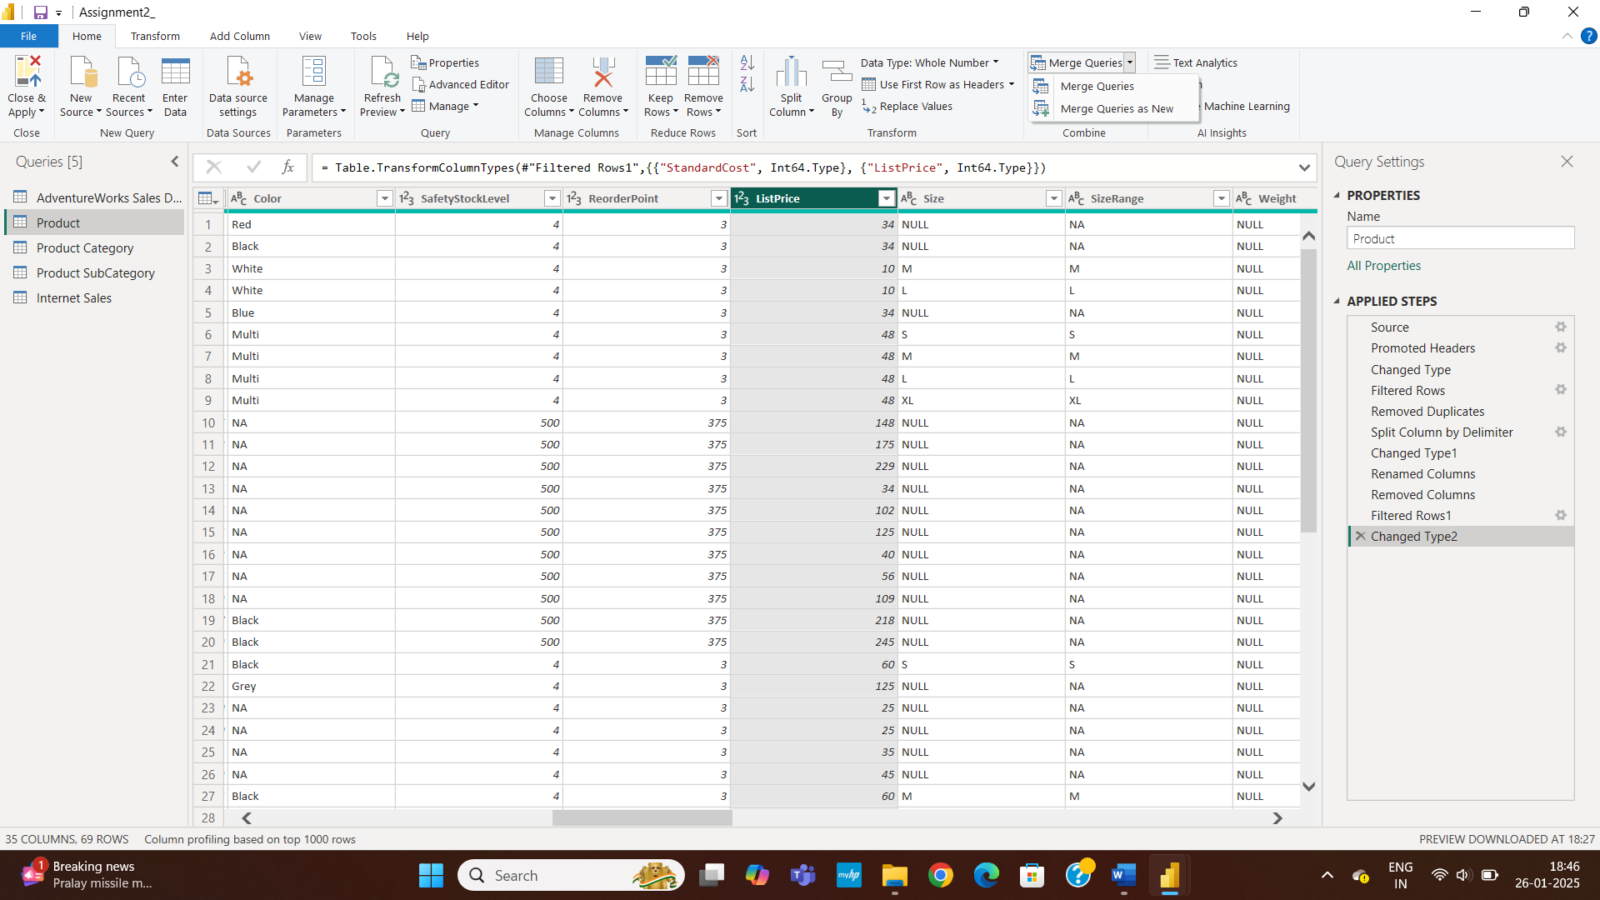

Step 30 : Click on ‘Merged Queries’ for merging two or more tables of same columns.

Step 32 : Select the table ‘product’ from the given option.

Step 33 : Now Select two or more columns as per your choice and perfom left outer join operation on it means it returns two or more same column values from the selected columns.

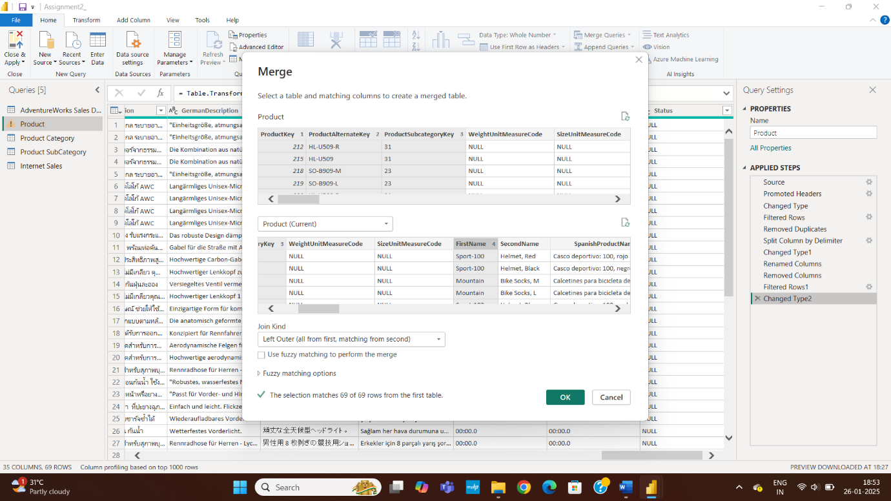

Step 34 : Our resultant column ‘filtered rows 1’ has merged the selected columns and operation is name as ‘merged queries ’.

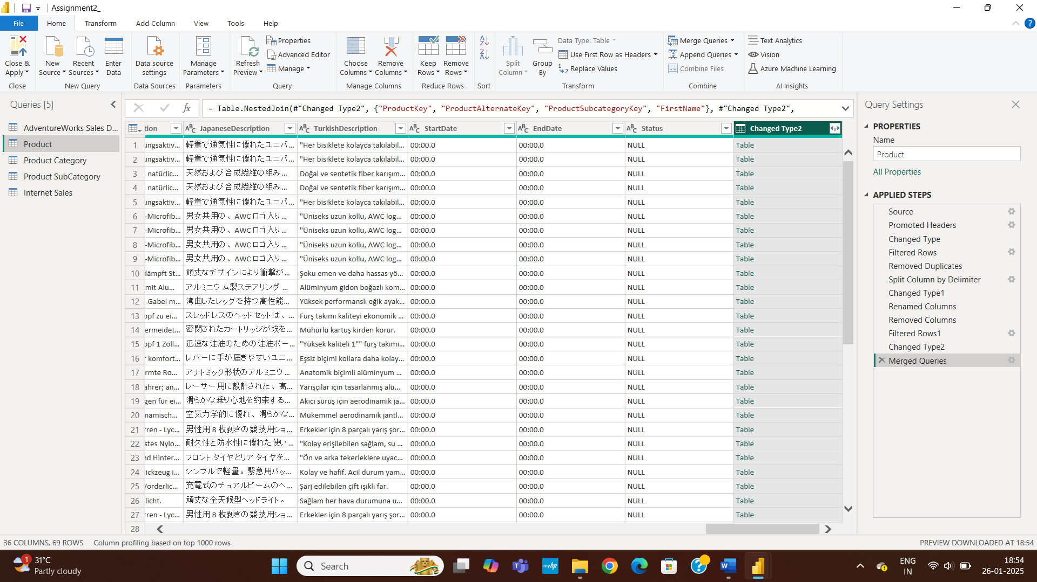

Step 35 : Save the Power Query Editor File by clicking on apply .

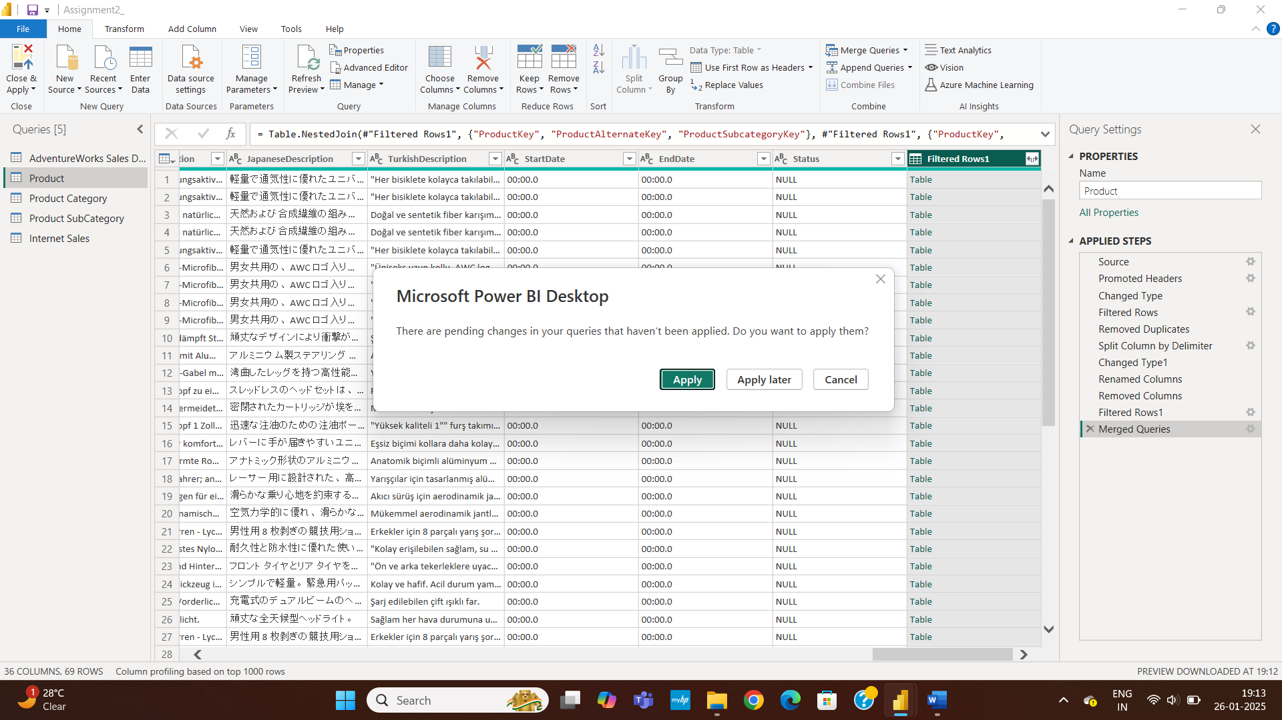

**Task 2:** Understanding Data & Data Modeling

1. Identify key tables: Fact (Sales, Orders) and Dimension (Customers, Products, Regions).

2. Define Primary & Foreign Keys and create relationships in Model View.

3. Implement Star Schema for better performance.

STEP 1: After A Loading A Internet Sales,Product,Product Subcategory, Product Category In A Power Bi File, Go In Model View.

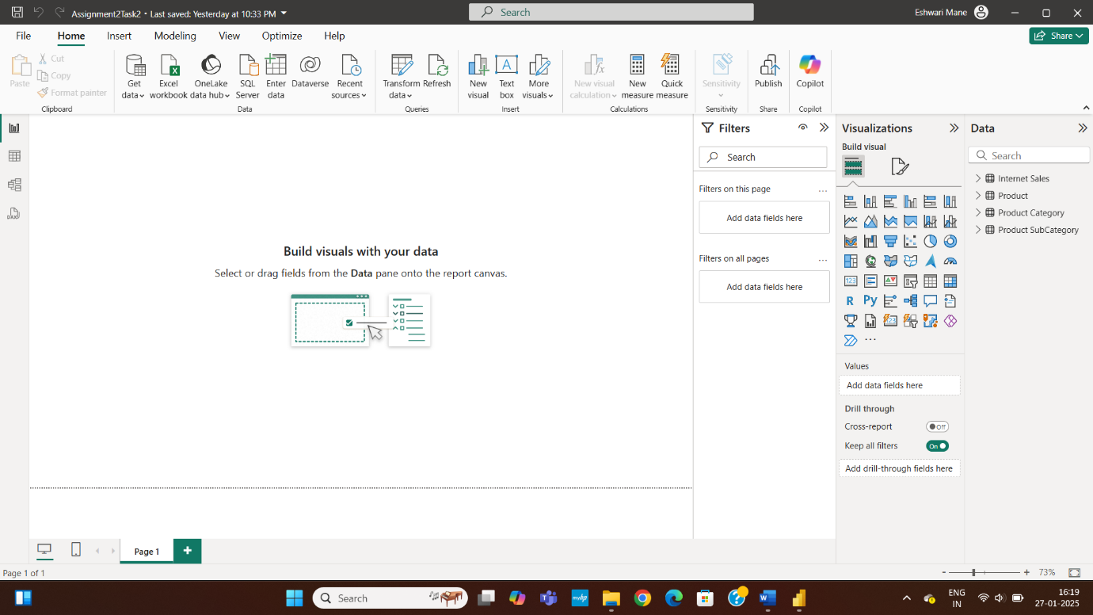

STEP 2:Here You Will See Power Bi Do Some Inbuilt Connected Table , Hence We Have To Do Remaining Connections.

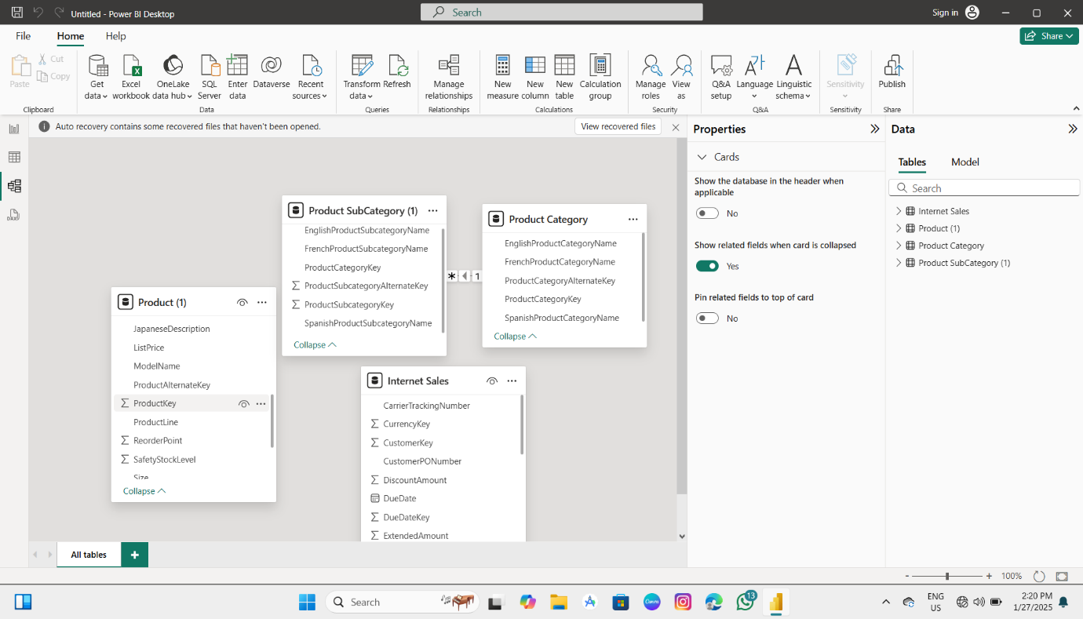

STEP 3:To Establish Connection Between Product Category And Internet Sale ,Drag Productkey Column To Productcategorykey In Product Category Table.

Note: Productkey Column Does Not Conatin A Null And Dublicate Values.

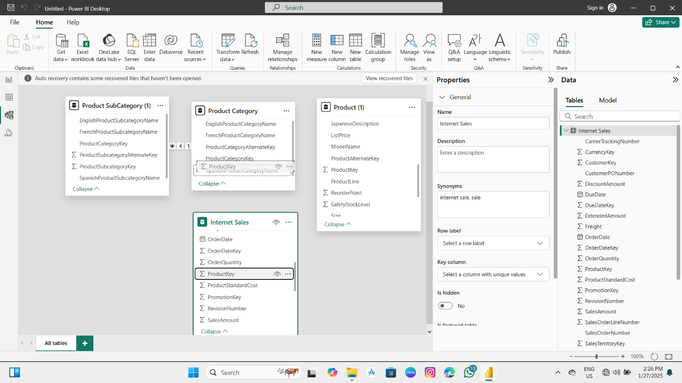

STEP 4:IF You Want To Modify The Relationship Then Modify It Her And After Click On Save Option.

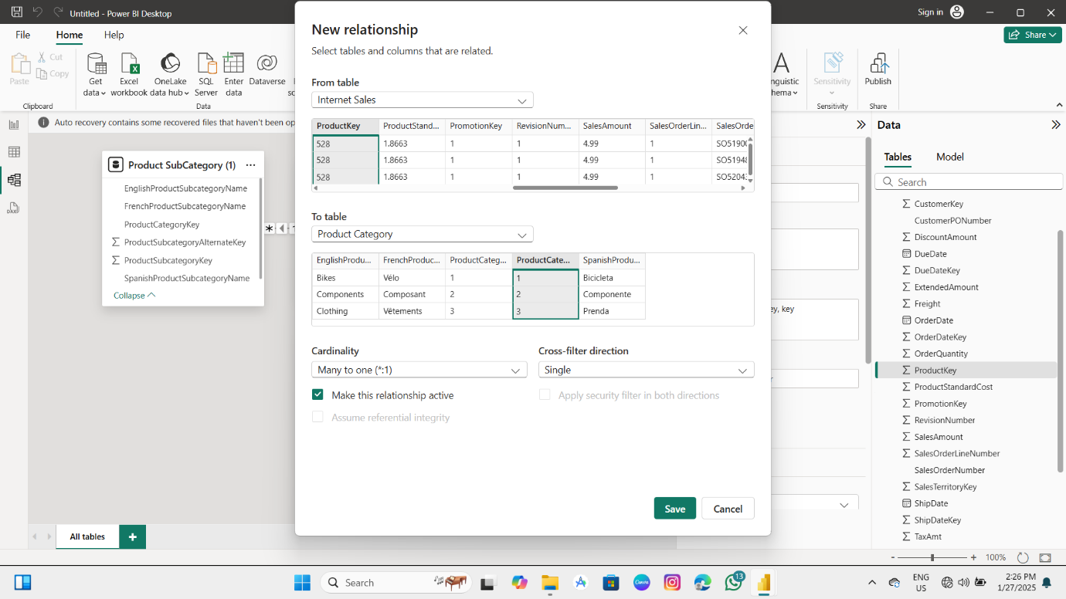

Step 5:Here You Will See A Connection Is Established In Two Desired Tables.

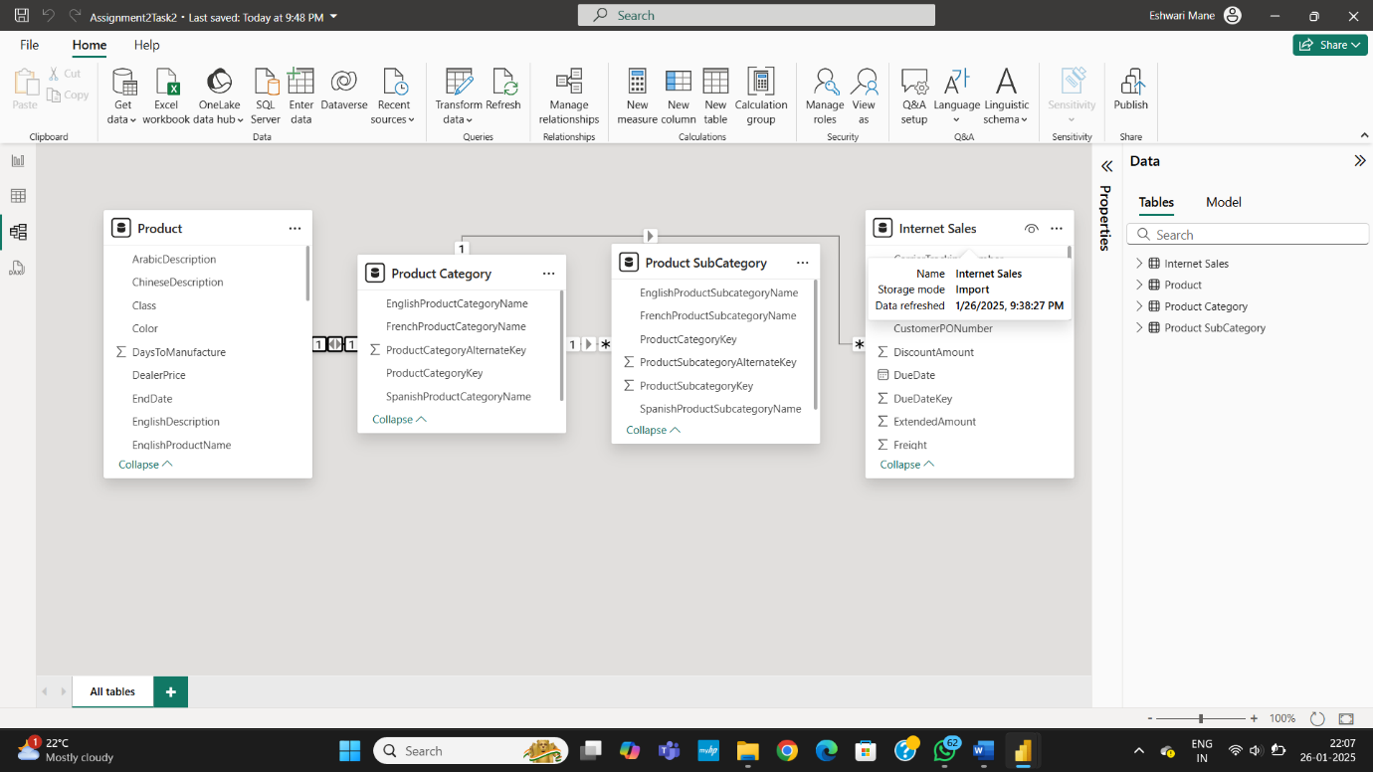

Steps 6: To Establish Connection Between Product Category And Product ,Drag Productkey Column To Productcategorykey In Product Category Table.

Note: Productkey Column Does Not Contain A Null And Dublicate Values.

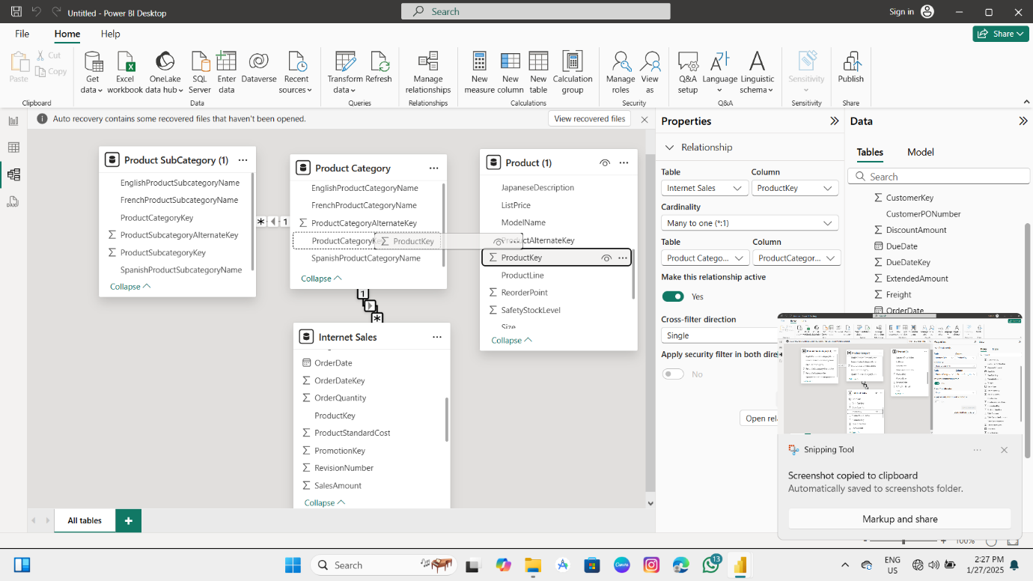

STEP 7:IF You Want To Modify The Relationship Then Modify It Her And After Click On Save Option.

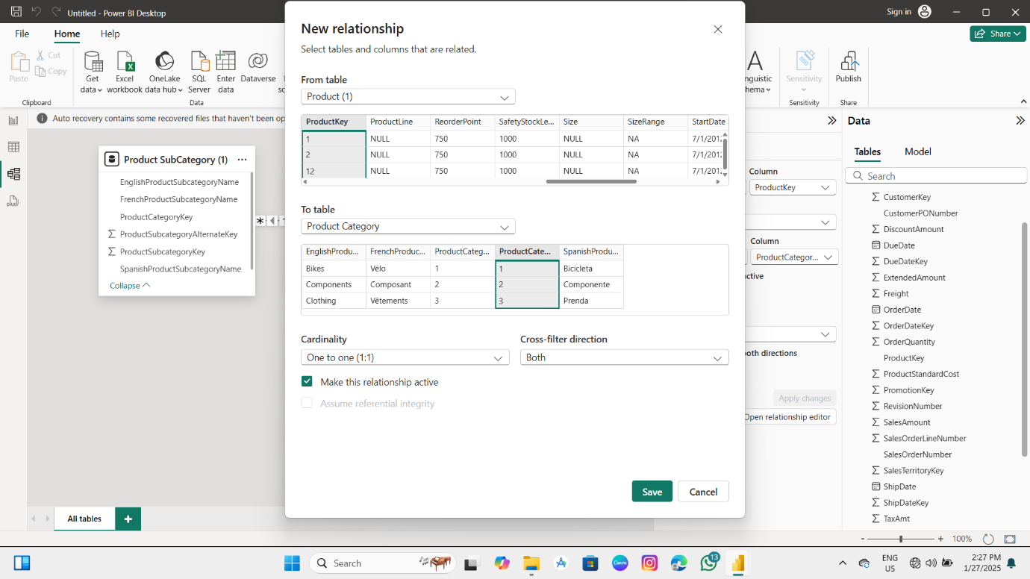

Step 8:Here You Will See A Connection Is Established In Two Desired Tables.

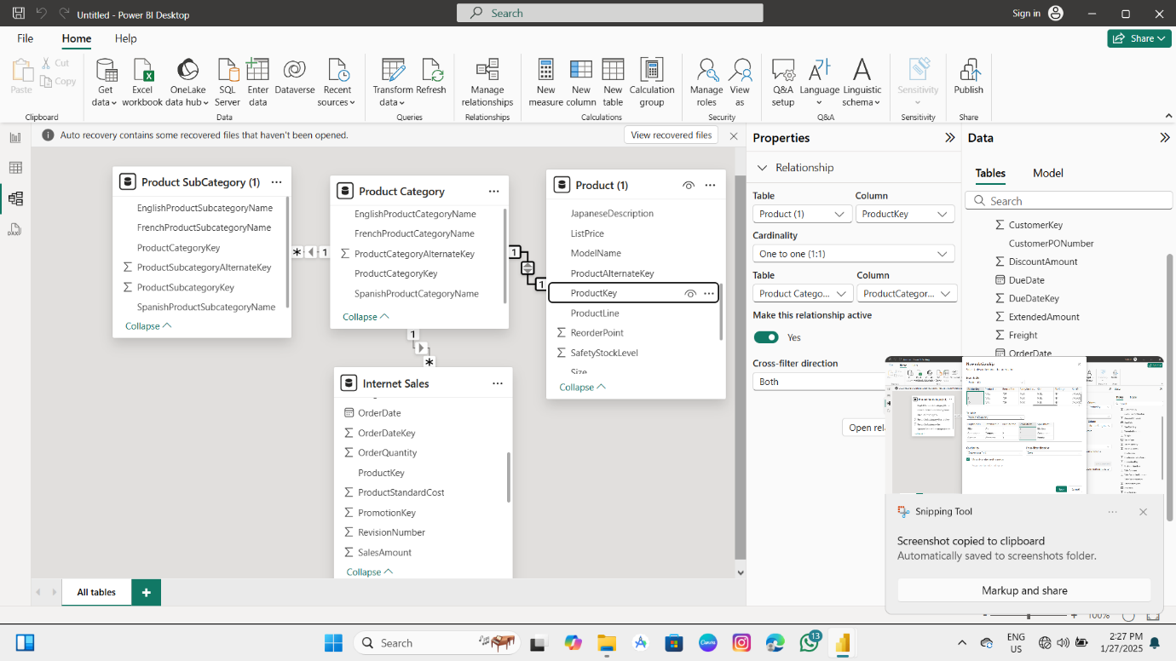

Here You Can See The Product Category Table Is Having Connection With All Of The Rest Tables.

**4. Explain why schema design is important in a short document (1-2 pages)**

In the world of business intelligence (BI), data is the backbone of informed decision-making. Power BI, a leading tool for data visualization and analysis, relies heavily on proper schema design to effectively transform raw data into meaningful insights. Schema design in Power BI refers to how data tables are structured, related, and organized within the Power BI model. Proper schema design is essential to ensure that data flows correctly through the system, facilitates intuitive analysis, and ensures optimal performance. This document highlights the key reasons why schema design is crucial for successful Power BI implementation.

**1. Data Integrity and Consistency**

Schema design in Power BI ensures that data integrity and consistency are maintained across the model. In Power BI, data is typically loaded from various sources such as databases, Excel files, or cloud-based services. Without a proper schema, there is a risk of inconsistent or redundant data, which could lead to incorrect analysis. By defining relationships between tables using primary keys, foreign keys, and measures, you ensure that data is correctly aligned and consistent throughout your reports and dashboards. This consistency helps prevent errors in calculations and ensures that the visualizations represent the true story behind the data.

**2. Efficient Performance and Faster Load Times**

A well-designed schema plays a crucial role in enhancing the performance of Power BI reports. As the volume of data grows, queries become more complex and can slow down report loading times and responsiveness. By organizing data into normalized or star schema structures, Power BI can process queries more efficiently. For example, in a star schema, the fact tables (which contain transactional data) are linked to dimension tables (which provide descriptive attributes). This structure reduces redundancy and improves query speed, leading to faster report generation and better user experience. Additionally, designing appropriate relationships and utilizing indexing on large datasets can significantly improve data loading times.

**3. Simplified Data Modeling and Analysis**

Schema design also simplifies the process of data modeling and analysis within Power BI. A clean, well-structured schema allows users to easily navigate and understand the data model. The use of simple and intuitive relationships between tables enables users to perform complex calculations, aggregations, and filtering with ease. For example, using a star schema allows analysts to focus on the core business metrics in the fact table while enriching them with details from dimension tables. A well-organized schema also helps avoid common pitfalls, such as circular dependencies or ambiguous relationships, which could complicate analysis and result in misleading insights.

**4. Scalability and Flexibility for Future Growth**

A good schema design in Power BI ensures that your data model is scalable and adaptable to future changes. As organizations grow, the volume of data often increases, requiring updates to the schema. A properly designed schema, such as a normalized or star schema, makes it easy to add new data sources or tables without disrupting the existing structure. The relationships defined in the schema are flexible, allowing users to expand the model as new requirements arise. Whether integrating new data sources or introducing additional calculations, the model will continue to function smoothly with minimal modifications.

**5. Enhanced Data Security and Access Control**

Data security is a critical aspect of any BI tool, and Power BI is no exception. Schema design plays an important role in defining who has access to specific parts of the data model. By structuring the schema into separate tables and controlling relationships between them, you can implement role-based access control (RBAC) to restrict access to sensitive information. For instance, you can design a schema where financial data is kept separate from non-financial data, and access to this data can be granted only to specific roles within the organization. This ensures that only authorized individuals can view or interact with confidential data, enhancing data security.

**6. Simplified Maintenance and Troubleshooting**

When the schema is well-organized, it makes the Power BI model easier to maintain and troubleshoot. With a clear structure, administrators can quickly identify areas of the model that need updating or optimization. This is particularly important as new data sources are integrated or business requirements change. Having a well-documented schema also helps ensure that new team members can easily understand the existing model and work efficiently with the data. In case of issues such as data mismatches or slow performance, a well-structured schema allows for quick identification and resolution of the problem.

In conclusion, schema design is fundamental to maximizing the effectiveness of Power BI. By ensuring data integrity, improving performance, simplifying analysis, providing scalability, and enhancing security, a well-thought-out schema is key to creating efficient and impactful Power BI reports. It also facilitates easier maintenance and future growth, making it an essential component for building long-term, sustainable BI solutions. Whether you’re designing a data model for a small department or a large enterprise, investing time and effort into proper schema design will pay off in the form of improved insights, better performance, and an overall more efficient Power BI environment.

**Task 3:** Implementing DAX Functions

1. Text Functions Create calculated columns using the following Text DAX Functions:

Step1 : Insert the datasets which are required to perform the DAX Functions:

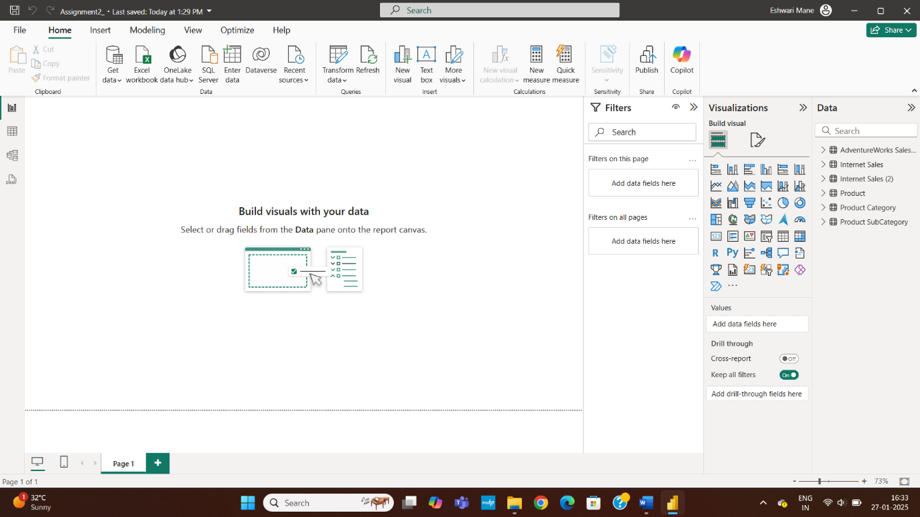

Step 2: Click on View Table and select the dataset from data on which we have to perform functions.

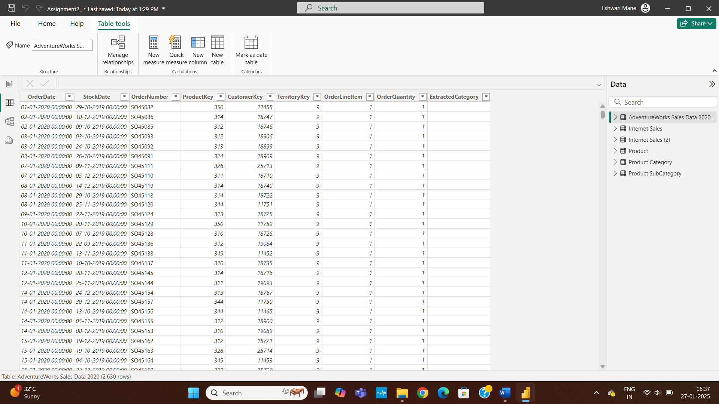

Step 3: Now click on new Column option and Enter the query to Extract the first 3 letters of Product Category:

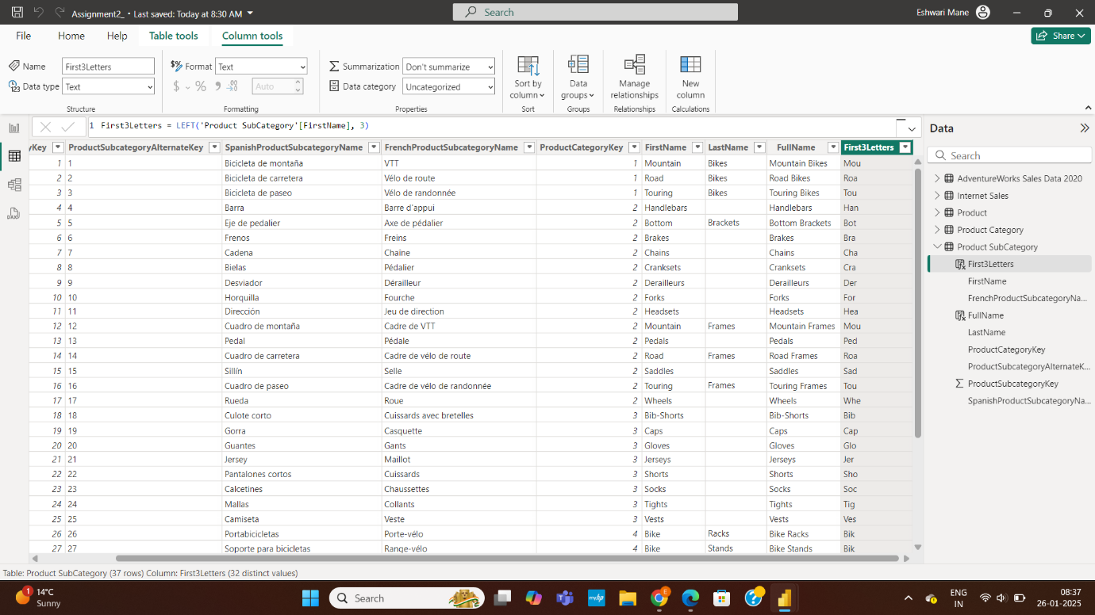

Step 3: Now click on new column again and enter the query to Create a full name column from First & Last Names:

For this first we will Split the column EnglishProductName into two columns and rename it as FirstName and LastName.

Step 4 : Now we will click on New column and Enter the query to combine the two table FirstName and LastName to produce one column of name FullName

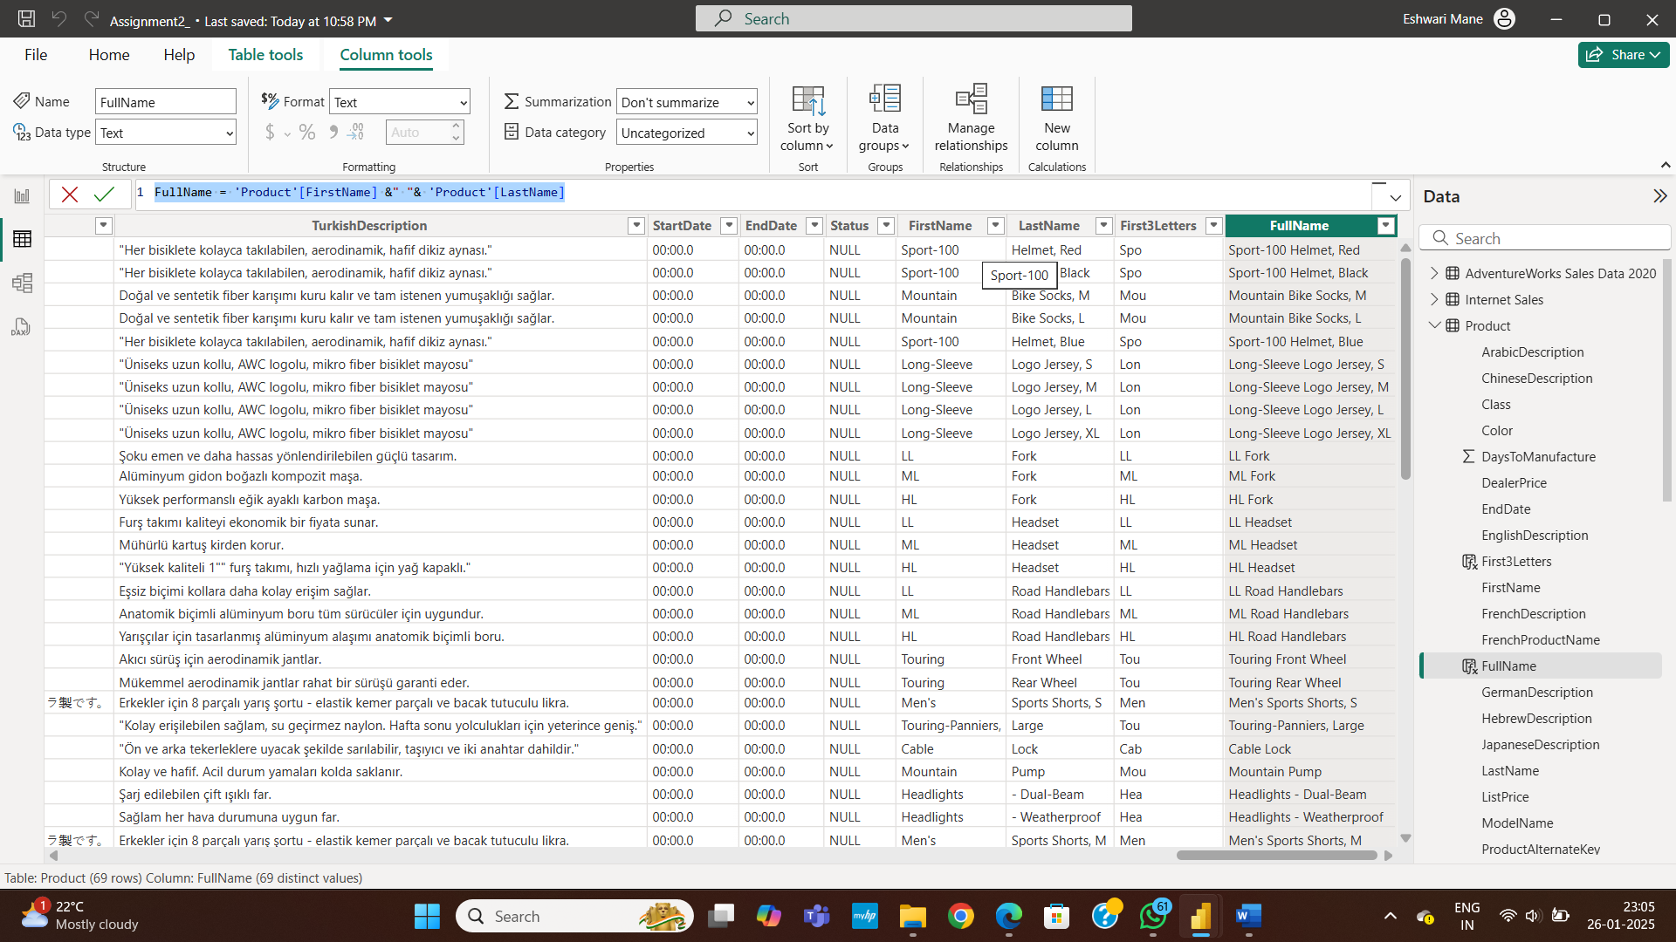

1. Logical Functions Use Logical DAX Functions for analysis:

Step 5: Again click on new Column and enter the query for Discount Category

1. Discount Category: Create a calculated column to categorize discounts

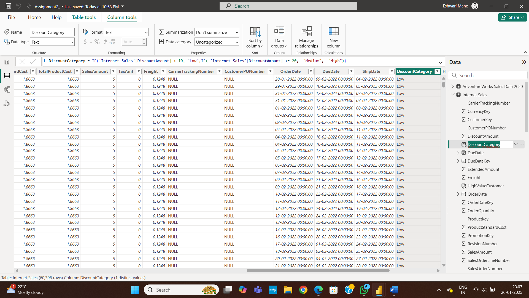

Step 6: To get column on High Value Customer column again click on new column and enter the query

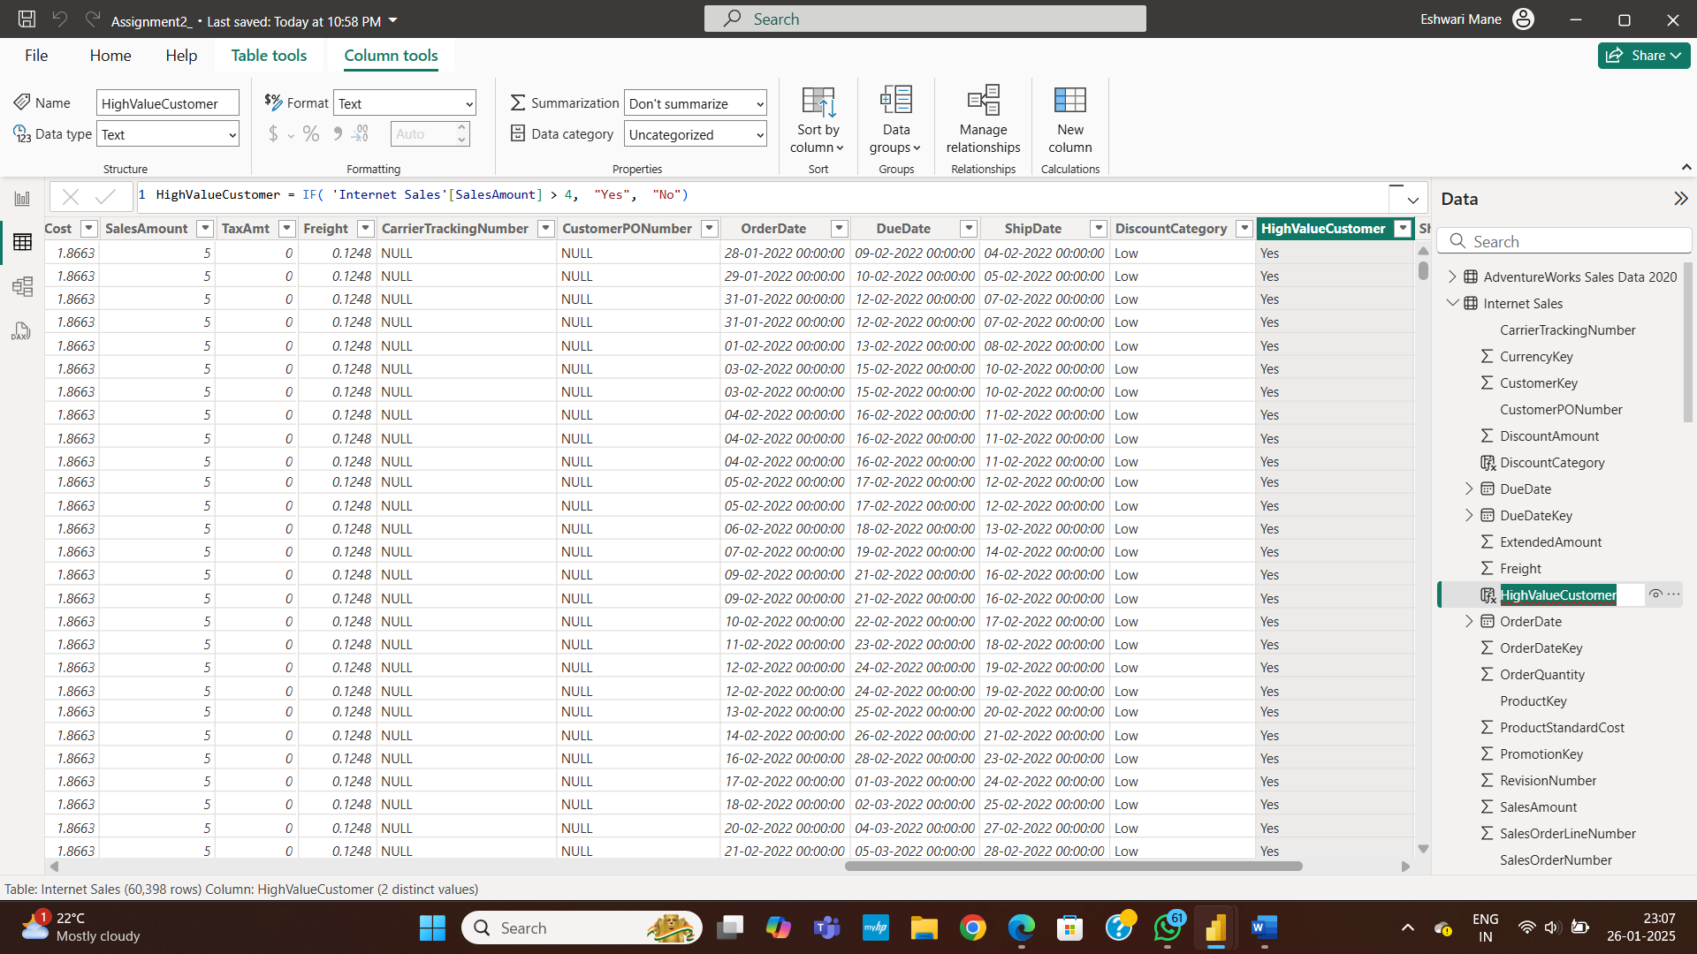

Time & Intelligence Functions Use Time Intelligence DAX Functions to analyze sales trends:

Step 7: To Calculate the Total Sales Last Year .Here we will click on new measure

And enter the query for it.and then enter

1. Calculate Total Sales Last Year:

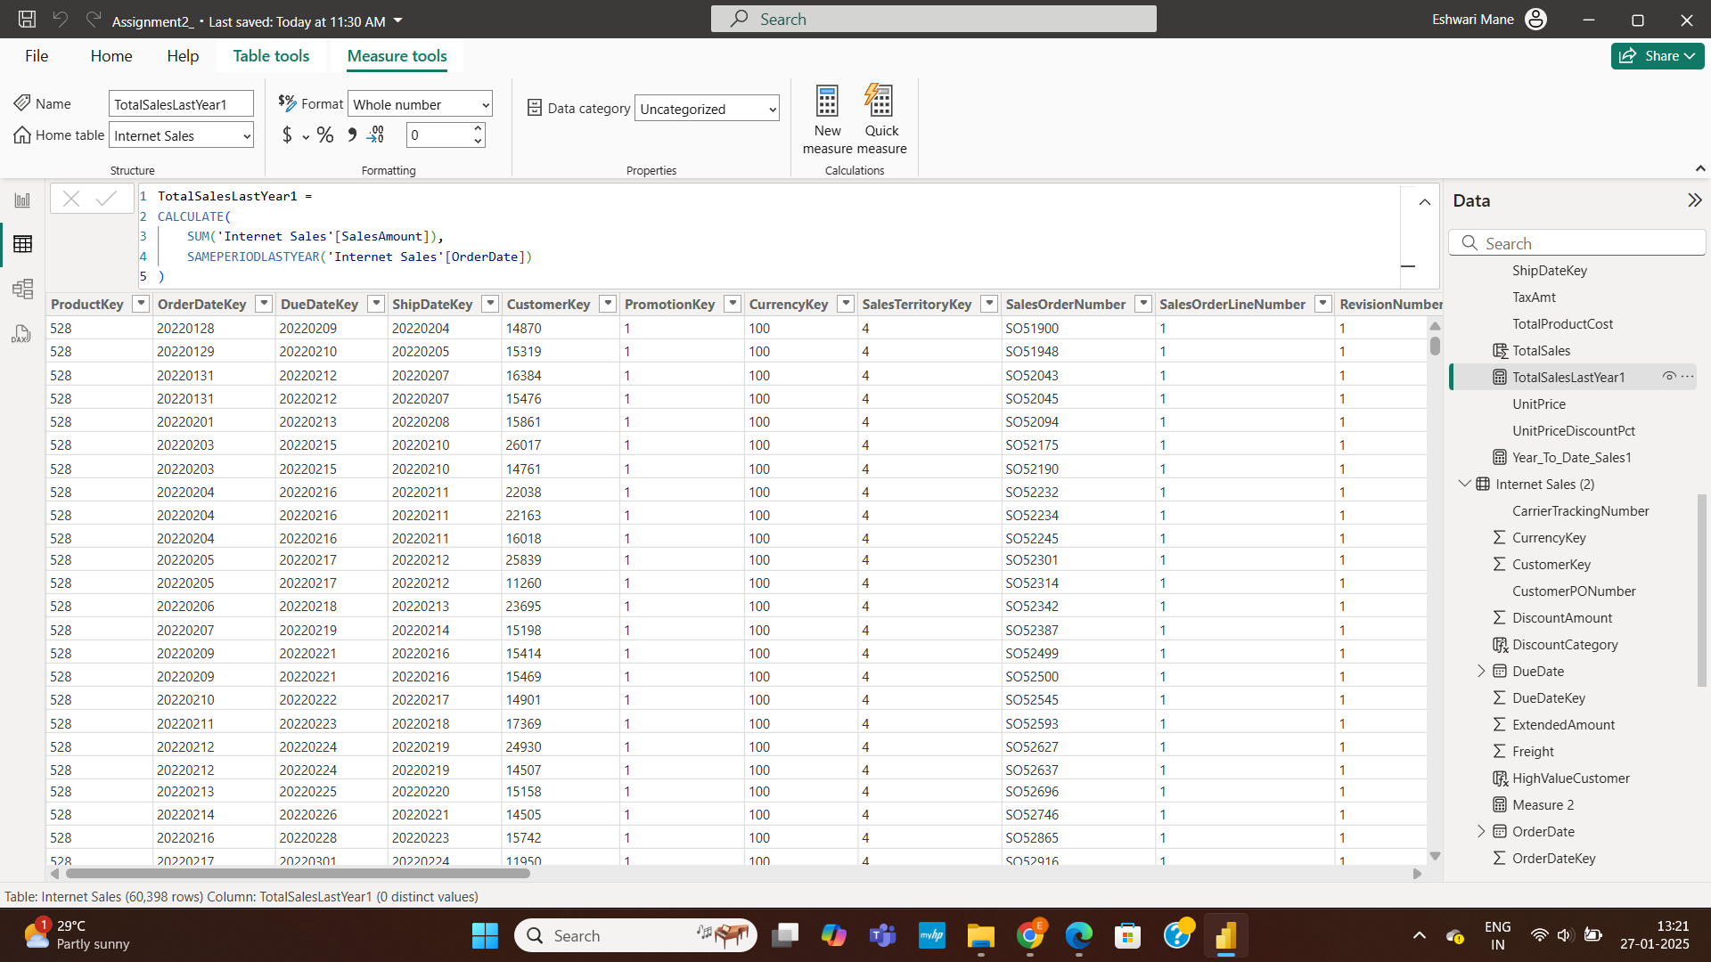Step 8:Same here click on new measure and write query to Find Year-to-Date (YTD) Sales: 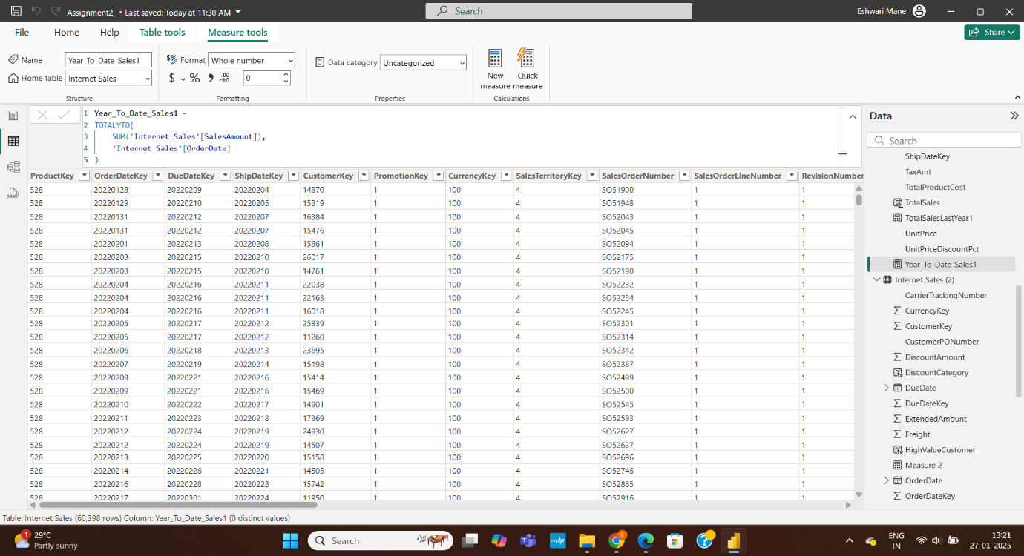

Step 9:Click on New Measures and enter query to Calculate Month-over-Month Growth

